


Aldridge Community Centre, on the

first Sunday of each month (unless otherwise stated)
at Middlemore Lane, Aldridge. WS9 8AN
Starting at 9.30am on
Sunday 7th January 2018
Sunday 4th February
Sunday 4th March

2018 Committee meetings
These will be on the second Tuesday of the month.
Venue: Aldridge Community Centre
Group Contact Details
Committee email: info@wgam.org.uk
The Group web site: www.iamroadsmart.com/groups/walsallam
or contact Newsletter Editor Sandie 01922 621592

For your 2018 diary
Tuesday 16th January
Venue: Aldridge C.A. Start time: 7.30pm

Talk about driverless cars (and hopefully how to keep away from them!). According to Wikipedia, the free encyclopedia, here’s a brief description for those of you who haven’t the foggiest about driverless cars (and that includes me!)

An autonomous car (also known as a driverless car, self-driving car, robotic car) is a vehicle that is capable of sensing its environment and navigating without human input. Autonomous cars use a variety of techniques to detect their surroundings, such as radar, laser light, GPS, odometry and computer vision. Advanced control systems interpret sensory information to identify appropriate navigation paths, as well as obstacles and relevant signage. Autonomous cars must have control systems that are capable of analyzing sensory data to distinguish between different cars on the road. (any clearer ? If not come along to the talk on 16th January )

1


winter / new year events

Date to be arranged
A talk about the effects of alcohol or drugs whilst driving or speed awareness
Date to be arranged: Talk by Steve Tyler, Examiner

New Year meal
This meal is will be at Moor Hall Country Kitchen Carvery. We will book a table for 20 for:
Date: Thursday 22nd February
The cost for the three course meal (starters choose from the salad bar or soup; main includes roasts, fish, or veggie option; sweets plus cheese and bics and coffee) is £16.50. We’ve been before and it’s a good meal.

However, I do need a £5 deposit per person from you if you wish to attend. You can either send this to me at my home address (last page of newsletter); give it to me at the talk on 16th January, or drop it into the Sunday Drives session at Aldridge Community Centre. The cut off date is Sunday 4th February. Thanks. Editor Sandie
Well done & Congratulations
on passing your test to

Chris Mansley
Chris passed 19/12/17 with a F1RST
Observer Simon Arnold. Examiner Gary Harris
Jon Barlow
Jon passed 11/11/17
Observer Josie Hubbard-Palmer. Examiner Ken Perry

Kate Awmack

From Martin Goad
When you read this it will be 2018 and Christmas a receding memory but, as I write, the run up to the big day is getting intense. I am hoping that Santa will bring me a nice, new car with all the latest bangs and whistles to replace my trusty, but basic model. My Focus does not even have the heated front windscreen that would have been so useful this December with the snow and frost that we had.
2

Secretly I do not know how I would cope with a lot of new technology. It took ages for me to realise what was going on with fog lights switching on and off as other drivers cars turned at junctions. You may know from my previous musings that I do notice how many faulty lights there are on cars these days, especially as the nights draw in. When I started to see these bumper lights going on and off I just assumed it was another lot of faulty electrics. I ought to have known better as cars are so reliable these days and it was a regular pattern and not just random happenings. Perhaps I am not as sharp these days as I once was.

To be more serious for a moment, I would like to hear from someone who has these lights to find out how useful they find them. As a detached observer it seems to me that the extra illumination of the roadside low down must have some safety benefits. Certainly, as advanced drivers, we would be looking in that area as we turn a corner in daylight to see exactly where the kerb is and at night we have less access to that information as it is dark. It is difficult to judge whether having this feature would persuade someone to buy a car with it in preference to one without it, but once one manufacturer includes it then others will follow.

I know my late father in law would not have been influenced, as he would have as little technology as possible when he ordered a car as there was “less to go wrong with it over the years”. His last car had manual wind front windows and this was only a few years ago. The cost of replacing complex items on a car can be prohibitive so it is a blessing that they are normally so reliable.

Well Happy New Year to you all. If I could suggest one resolution for 2018 it would be get to know and use all the features of your own vehicle. Safe driving this year no matter what level of technology is in your car.
Martin Goad


VISIT TO RAC BESCOT ON 17TH NOVEMBER
IAM Road Smart had organised a special day at the RAC H.Q. Bescot. Luckily for us they had two spare places at the last minute and Josie and I were invited as we were local. Paul Wolsley, from IAM H.Q., was there to welcome us along with three managers from the RAC. We were based in the conference room where we were given talks by the managers about many aspects of their work. We toured the building and spent time with an RAC Patrol Officer, his Recovery vehicle and all the latest gadgets they use to get us back on the road. We were also treated to lunch and cakes.

The RAC is owned by Singapore Sovereign Wealth Fund and CVC Investment Fund. The building is divided into Bescot 1 for breakdowns and Bescot 2 for Business and corporate. Bescot controls breakdowns for the North of the country while another centre down south manages the South of the country. The Automobile Club of Great Britain started in 1879 with emergence roadside starting in 1912. Fuel patrols began in 2009 and the universal spare wheel was introduced in 2013. With ATS universal tyre patrols started in 2015.
3

They commented that the public cannot manage the new flat tyre systems on their cars which replaced the spare wheel. Patrols now try to make permanent repairs at the roadside wherever possible and carry the parts they have observed fail for each car. They have two vans that charge stranded electric vehicles. These have very little use. as drivers of E V’s seem to plan their journeys well.

The RAC receives 4.5 million calls a year answered within 20 seconds with 2.3 million jobs attended. Help over the phone is sometimes enough to get the motorist back on the road. The RAC has 1500 patrol vans, 18 mobile tyre patrols, 2 EV charges, 56 flat bed recovery vehicles and 26 fuel patrols.

There is ongoing feedback between vehicle manufactures and the RAC over the problems with vehicles picked up by the patrols. With the latest cars fault codes are used to diagnose problems using the vehicles telematics box. This means patrols may know the problem before they get to you and can therefore have on board the correct spares.

We were told that £100 million is now lost in road tax since the abolition of the tax disc. With modern cars having so much more technology and customers not fully understanding their vehicles, battery callouts are more common. Many new diesel cars have an Ad Blue tank which if not topped up will bring the car to a standstill. Ad Blue is added to the exhaust to reduce pollution.

They find that the public do not come prepared for breakdowns eg. Warm clothes. Patrols have found strange things to deal with – squirrel stacking nuts in the air intake; snake in the car; a child had removed all the fuses; delivering a bride to her wedding; child that had swallowed the car’s immobiliser chip and a dog that had locked the doors from the inside.

A very interesting visit indeed – many thanks to the RAC for their hospitality.
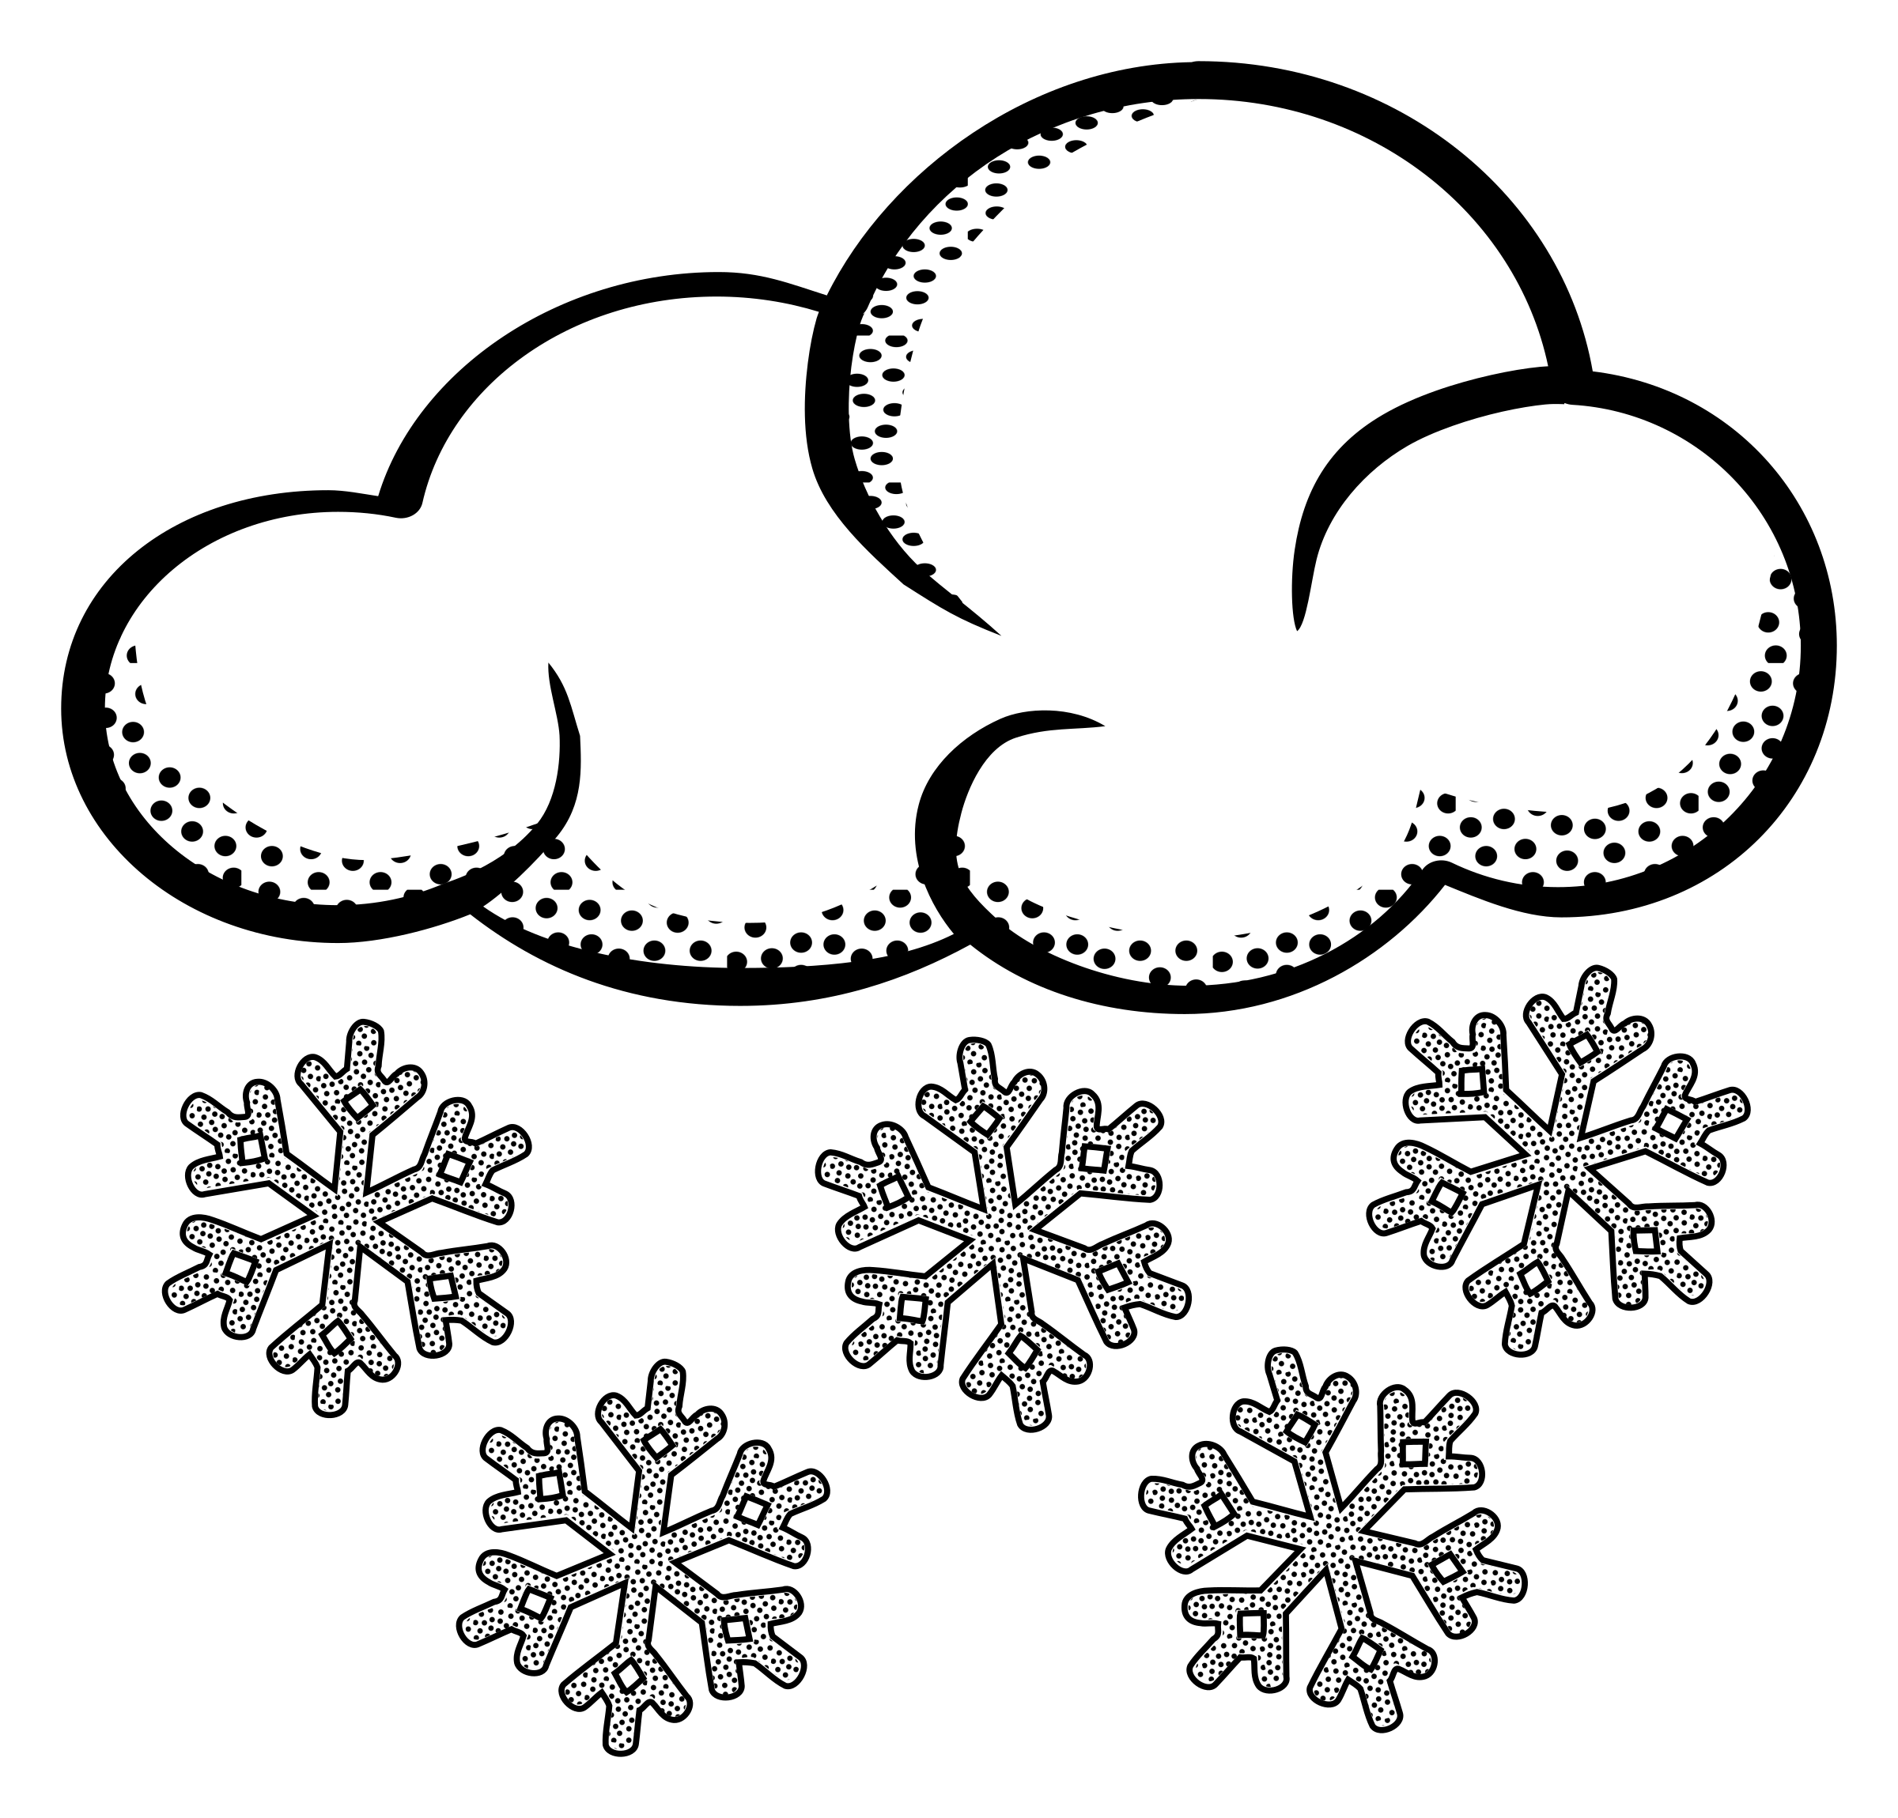
Mike Bentley

Snowing …

there is something we CAN do
IAM RoadSmart brings you expert advice on driving in snow. Best advice is to avoid travelling in extreme weather. If no one is moving, you just add to the problem - so listen to travel advice. If you do have to travel in bad weather, plan your journey thoroughly. Think about where you are going and what it will be like all the way along the journey. If you can, avoid travelling on less-used roads or country lanes as these are less likely to be gritted.

Before setting off, clear all your windows and mirrors fully. Clear off snow piled on the roof of your car and the bonnet too, as it can fall and blow on to the windscreen. Don’t leave anything obscured. Start your car gently from stationary and avoid high revs. If road conditions are extremely icy and you drive a manual car, you should move off in a higher gear rather than first gear. You should stay in a higher gear to avoid wheel spin. It’s important you get your speed right when travelling in snow. Never drive too fast that you risk losing control, and don’t drive so slowly that you risk losing momentum for getting up a slope.

Increase your following distance from the vehicle in front of you. It may take up to 10 times as long to stop on snow or ice build this into your following distance – this will give you more time to slow down using engine braking which is less likely to induce a skid.
4

Make sure you slow down sufficiently before reaching a bend so you have enough time to react to any hazards that appear as you go round it – and so you do not skid as well. You should have finished slowing down before you start to turn the steering wheel.

If you break down or have to pull over on a motorway or dual carriageway, you should leave your vehicle and stand to the safe side of it - ideally well over the armco to the nearside of the road, but not in front of it, when waiting for help.

At the very least you should have a shovel, torch, blanket, jump-leads and tow rope. You should ensure your mobile phone is fully charged, and the number of your recovery organisation is saved into it. A bottle of water and a snack may also prove useful and don’t set out without knowing the locations of petrol stations on your way.

This all might sound obvious, but too many of us forget to do any of this. Don’t be one of the ill-prepared, and listen to the weather forecast for the whole length of a winter journey to help you prepare for it.
(Dear reader: after reading this -think. Do you still really want/need to go out?)


MOT 2018: what the changes are

and what they mean for drivers
Next year the UK government is planning to bring in MOT changes. The tweaks to the annual vehicle roadworthiness test have been designed to make life easier for drivers preserving historically interesting ‘classic’ cars. Critics say they will increase the number of unsafe cars on the country’s roads. Further changes are afoot too. The Driver Vehicle Standards Agency (DVSA) is currently considering the results of a consultation paper on the age that cars first take their MOT. Read on to find out more about the changes.

What are the changes to the MOT 2018?
Owners of all cars registered after 1960 need to put their car through the annual MOT test. From May 2018, cars that are more than 40-years old (first registered in 1978) will no longer need an MOT certificate. This will continue on a rolling basis meaning the following year it will be cars first registered in 1979 and so on.

Why has the government done this?
The government believes cars that are 40 years or older are of historical interest. Because of that it thinks these older cars are well maintained voluntarily as the vast majority are owned by enthusiasts. It also claims older cars aren’t used regularly. And when they are used, it’s usually for short journeys. Changing the exemption to cars that are 40-years old also ties in with the current car tax rules. And modern cars are very complex, requiring increasing levels of computer diagnosis. This means garages frequently aren’t set up to test much older cars.

What will the impact be?
At the moment there are 197,000 vehicles on the road that don’t need to have a valid MOT certificate. By changing the year when an MOT is needed, a further 293,000 vehicles are expected to be added to the list. That is around 1% of the number of cars on the road. It means now 490,000 cars will no longer have an MOT certificate. However, the onus will be on the owner to ensure their car is roadworthy.
5


Dear Reader
You’ve woken up late, you’re in a rush.
You get out to the car and…it’s frozen!
Here’s what you could have done the night before………

Sock your wipers
What about those annoying frozen wipers? Easy. Grab an old pair of socks (maybe that novelty pair you received last Christmas?) and simply pop them over the end of each wiper when you park up in the evening. No more frozen wipers!

The freezer bag trick
Frosty wing mirrors can be a real annoyance. Scraping off the ice is a pain, and then you misalign your mirrors and have to fuss around getting them back into the right positions. Instead, just take a couple of freezer bags and put one over each wing mirror in the evening. Come the morning your mirrors will be clean and clear.

Editor Sandie's observations
(or in other words a good moan!)

→ Are indicators fitted to vehicles these days ? The large amount of drivers who do not use them and assume you are a mind-reader !!!

→ Vehicles without lights in even the most gloomy weather or time of the day - and usually they are dark coloured vehicles too. Obviously these vehicles probably don’t have indicators either !

→ (and this is where I apologise in advance to anyone in our Group who owns such a vehicle - sorry): 4 x 4 cars ! I am sure these are superb for higher, good driving visibility etc from the driver’s point of view, however, from the point of view of someone (me) in a lower, smaller car it is horrible (and dangerous) to have the headlights of these 4 x 4 vehicles shining directly into your eyes as they are coming towards you, especially the newer type of headlights (can’t you tell I’ve experienced this ! more than once)
END OF MOAN !!! (until the next edition !)

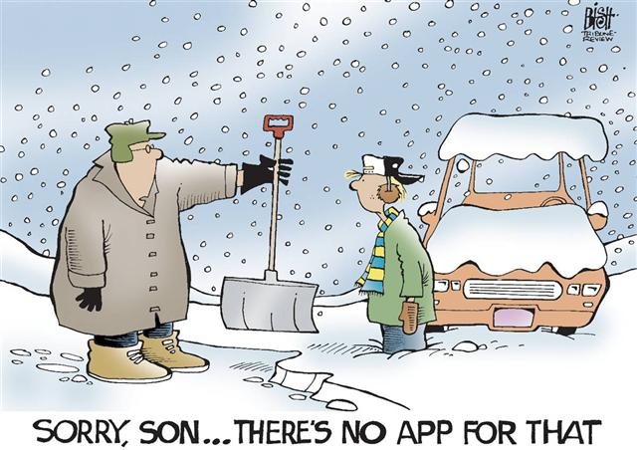

Top tips to prepare for winter driving

Winter-related car insurance incidents typically increase from late October, but there are plenty of simple steps that you can take to prepare for safe winter driving.

Before you venture out in the car as the chill sets in, ask yourself the following questions:

6

Is your car ready for winter?
Darker nights and adverse weather conditions can make driving particularly hazardous in winter months, but making sure that your car maintenance is up-to-date could help you to avoid an accident.
- Check your windscreen, door locks, lights, brakes and mirrors are all clean and in good working order.
- Make sure the mirrors are clear, the windows are demisted. Be able to see. Clear all snow and ice from all your windows
- Make sure that lights are clean and number plates are clearly visible
- Inspect the walls, pressure, treads and look for any splits on all of your tyres, including the spare one
- Remove all snow that might fall off into the path of other road user
- Check your planned route is clear of delays and that no further snowfalls or severe weather are predicted.

Are you prepared for an emergency?
It’s great to have comprehensive car insurance, including breakdown cover, but make sure that you keep your policy number and rescue details in the car. No matter what time of the year it is, it’s also a good idea to leave a high-vis jacket, warning triangle, first aid kit and torch in your car. During winter months, you’ll need to add de-icer and screen wash. Just in case you do have to wait in your car in the cold, it’s wise to keep blankets, food and water in your vehicle too.

Dear Reader ...
(the absolutely nothing to do with motoring bit)

Here are a few profound thoughts to inspire you in the New Year (or at least with which to bewilder your family and friends )

→ Tomorrow, is the first blank page of a 365 page book. Write a good one.
- Brad Paisley
→ Cheers to a new year and another chance for us to get it right.
― Oprah Winfrey
→ Each New Year, we have before us a brand new book containing 365 pages. Let us fill them with all the forgotten things from last year—the words we forgot to say, the love we forgot to show, and the charity we forgot to offer. ― Peggy Toney Horton

And finally………
My new year’s resolution is to stop lying to myself about making lifestyle changes !!!

7

Group President: Trevor Poxon MBE
Chair: : Martin Goad  120 Hednesford Rd, Brownhills.  01543 371516 Email: martingoad@mail.com | Committee Member: Kath Hawker  8 Fallowfield Road, Walsall. 01922 62245
Group Secretary: Josie Hubbard-Palmer | Committee Member - Gill Essex
Treasurer - Karl Spooner  26 Woodside Close, Walsall 0121 357 4356 | Committee Member: Paul Honeghan
Chief Observer & Committee member:  Sarah Harrison  Black Bryony, Grove Basin, Lime Lane, Pelsall,  nr Walsall 07775-694625 | Committee Member: Alison Kimberley  Co-opted Members: Peter Browne
Assoc Co-ordinator: To be appointed  Committee Member: Chris Rice  Group Registered Charity no. 1082326 | Newsletter Editor & Minutes Secretary  Sandra Wootton  70a Bescot Road, Walsall 01922 621592  email@sandrawootton.flowers@gmail.com
The opinions expressed in this Newsletter, which is published by the Walsall Group of Advanced Motorists, are those of the Editor and individual contributors and do not necessarily represent the views of the Institute of Advanced Motorists Ltd. Data Protection Act: We are obliged by law to inform members that their membership details are held on computer disc. This information is for group administration only. If any member wishes that their details are NOT to be held on computer disc, please inform the Editor forthwith.

