


Aldridge Community Centre, on the
first Sunday of each month (unless otherwise stated)
at Middlemore Lane, Aldridge. WS9 8AN
Starting at 9.30am on
Sunday 4th November
Sunday 2nd December
Sunday 6th January 2019
Contact information:
www.iamroadsmart.com/groups/walsallam
www.iamroadsmart.com/groups/walsallam/about-us/our-community
Details also on the Walsall Group web site https://www.iamroadsmart.com/groups/walsallam

Did you know under www.iamroadsmart.com/groups/walsallam/about-us/our-community back copies of the newsletter are available and details of events will be published once confirmed.

2018 Committee meetings
These will be on the second Tuesday of the month. Venue: Aldridge Community Centre

The remainder of your 2018 diary
Quiz Night / Fish & Chip Supper:
Tuesday 6th November
Do you have lots of useful bits and pieces of knowledge tucked away in your brain-box ??? We need you at our next Quiz Night. This is a really great fun evening. £5 per person (includes fish & chip supper) Venue: Aldridge CA

2019 events we are working on:
New Year meal:
Obviously this will be weather dependent - if the winter is anything like last winter, the New Year meal might be in February or March !!! However, if you have any suggestions for a good meal venue, please don’t keep it to yourself, let us know.
Dear Reader
Well, summer has been and gone. Do you have any memories of visits / outings / holidays / experiences you would like to share with us? Good or bad (if bad you can get it off your chest ) Let’s hear from you – please
2018 Committee meetings
These will be on the second Tuesday of the month. Venue: Aldridge Community Centre

1


Martin Goad’s

We had a great talk from Robbie Downing which focussed mostly on how to progress with to Master`s. We had a big audience from across the Midlands which shows that there is a strong interest from drivers and riders who want to develop their skills to the highest level. Going for Master`s is just one way of improving skills, but I want to promote another in this edition of the newsletter, becoming an observer.

We have a dedicated team of observers who work in the group, and sometimes beyond, to support associates as they progress to their advanced test. Some are also training and supporting other observers as they move on in their own observing. What is in it for them?

Well, firstly, there is the satisfaction of learning new things and becoming a better advanced driver. To become an observer you need to go through a training process and an assessment to get an Institute of the Motor Industry (IMI) qualification. There are two levels, Local and National. The local level is assessed within the group by our own more experienced observers, who also provide the training. Many Local observers then go on to qualify as National observers, but only if they want to. The IMI status is nationally recognised.

Secondly, preparing people the advanced test is at the core of what we do and is one of our stated aims, so being at the heart of that, as an observer, is very satisfying. It is great to see the way an associate pushes their own learning forward and becomes a better driver in the process. Friendships are made and it is really interesting to meet past associates and catch up with their news. I nearly said it is nice to bump into past associates, but that could be giving the wrong road safety message.

What about the demands of being an observer? You have to be able to give some of your time, to come on the first Sunday morning each month and to go out on drives with associates in between. Typically an observer has one associate allocated to them at a time and they would aim to go out for a drive for a couple of hours once a week. We do have observers meetings for updates and training, but only a couple of times in a year. As set out above, there is some training and a qualification process, but you would be well supported by other observers and able to fit it into your own timetable.

From my own experience I can say that the benefits far outweigh the demands and observing is something I really enjoy doing. If you are interested we are looking to increase the observer team so would love to hear from you. Contact me or Josie, or come along on a Sunday morning and go out to see an observer in action.

CONGRATULATIONS ON PASSING
YOUR TEST PASS
Alan Prosser
on 10th September.
Observer: Martin Goad Senior: Glynnis Jeavons

2

An Evening with Robbie Downing
Our Group hosted a very well attended meeting held at Calderfields Golf Club on Thursday 18th October. The meeting was attended by about 50 members made up of representatives from several Midlands Groups. Robbie Downing is our Area Service Delivery Manager.

The following are notes made from his talk and are by no means comprehensive: Robbie began by pointing out that both Masters and Fellows are members only products and they work through a one to one mentoring process. Masters is the highest civilian driving / riding qualification ( not a police course) and has a 90 minute test. There are two levels of pass – pass or distinction. The system works with the applicant going to the mentor which can be quite a distance away which has the advantage of driving unfamiliar roads. Masters but not Fellows need a good knowledge of Roadcraft.

On the Masters test candidates are marked on 27 categories. After the test there is a de -brief lasting one hour. If you are successful a Masters lasts 5 years. Examiners look for a safe, legal and systematic drive. This should be smooth, systematic, polished and flowing. ( Quiet Efficacy).

Candidates should get up to the speed limit briskly, make safe progress while recognising opportunities. Observation, anticipation, planning and awareness should be consistent with vehicle speed. Sound judgement of vehicle speed and distance required. Fluent, relevant and continuous commentary would be necessary. A knowledge of your vehicles dynamics. Cars and bikes.

Robbie spoke about cornering stressing the importance of observation, not going too fast in to a corner , correct positioning and matching speed to limit point. ( speed before gear)

Overtaking opportunities should not be hunted for – they are few and far between. Consider your closing speed with the vehicle coming towards you. For motorcycles filtering is overtaking and motorcyclists should make sure the manoeuvre is safe and legal and they should consider what would be achieved and the public’s perception of their move. Robbie pointed out the danger of following too close behind a lorry as it hides you.

For those wishing to take the Masters test this can be done with test only or with mentoring the cost being £299. Robbie advised candidates to come prepared to pass. Don’t change what you normally do and relax and enjoy.

Martin Goad thanked Robbie very much for his talk which was followed by a big round of applause.

A WARM WELCOME
TO OUR NEW ASSOCIATES
Jean Tansley;
Jennifer Bratt.
Silvena Nelson;
Mandeep Singh;
Matt Wilkes;
Paul Caine;
Kevin Jennison;
3
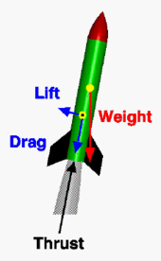
Visit to Leicester Space Centre

On Thursday 13th September a mini bus with 15 members and associates from the Group ventured off to Leicester to tour the space centre and what a splendid outing it was. First of all many thanks to Fred for driving us there.

What was there ?
Galleries with all aspects relating to space and space travel; crammed full of space suits, rockets, satellites and meteorites and an incredible Rocket Tower (yes, a genuine rocket) and best of all the Sir Patrick Moore Planetarium. Overall - Exhibits and visitor activities covering space flight, astronomy and cosmology. There are also the usual gift shop and a restaurant. This centre was a space research programme in partnership with the University of Leicester.

Where to start ? (after a cup of coffee of course)
A tour around all the galleries on the ground floor, gazing in awe at the space suits, competing on the inter-active galleries with the couple of coach-loads of schoolchildren who were thoroughly enjoying themselves!. The Centre has on display one of only three known Soyuz spacecraft in the West.

Up in the lift to the top of the rocket which is attached to the side of the building. There was a memory-jogging display of the history of space travel and photographs from that era. In one section – which was a depiction of a room from that era – there was a small manual typrewriter. A young girl was trying to put paper in it and I showed her how, saying I had one of these at home and learned to type on it. She replied “oh cool, did you really” That made me feel SO old.

For me the best bit of the whole visit was the session in the Planetarium – my first visit to one of these where we were treated to the history of the universe and how earth evolved.

If you have youngsters in your family (or grown ups) a visit to the Space Centre is a must -
a fascinating and educational day out. Thanks to Chris Rice for organising - Sandie.

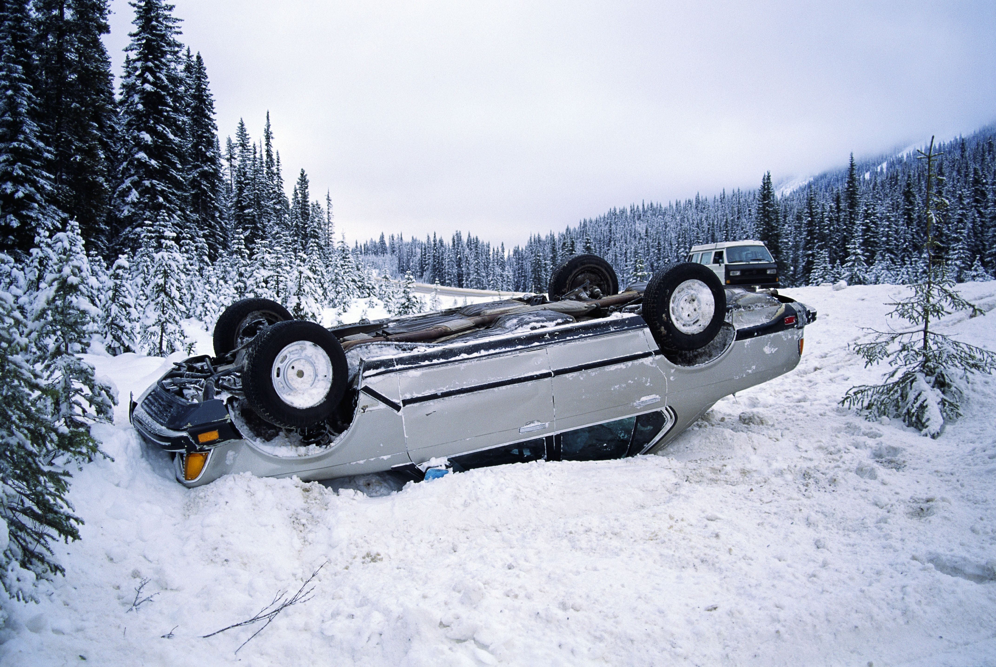
Tips from IAM RoadSmart
Don’t lose your grip this winter

Winter brings with it difficult driving conditions, so this is a good time to remind everyone how to drive safely when the temperature drops below zero. When we expect freezing conditions we normally get a weather warning from the Met Office, however you should always take extra care when travelling in winter. IAM RoadSmart’s head of driving and riding standards, Richard Gladman, is offering advice to motorists to better cope with driving on road surfaces that are covered in frost, ice or snow.

If the weather conditions are severe in your area, you should take notice of police advice and simply do not travel. However, in exceptional circumstances if you must go out then make sure you drive safely with extra caution on icy roads.

4

Tips from IAM RoadSmart
Don’t lose your grip this winter
At least triple your stopping distance and approach every junction expecting to stop well before the stop or give way line (it can take up to ten times as long to stop according to Highway Code advice). Every steering, acceleration or braking input should be as smooth and gentle as possible and select 2nd gear when you pull away in icy conditions (less torque will help prevent wheel spin).

Salt will often make the windscreen, headlights, number plate and rear parts of your car very dirty. Cars without headlamp washers, for example, will lose an estimated 40% of luminosity and possibly all their focus in about 20 miles on a damp, gritted motorway.

When travelling long distances it is advised that you stop regularly at service stations to clean your windscreen and headlights with a clean cloth. Or keep a filled bottle of water in the car boot to give your lights, windows and mirrors a quick wash over – a handy investment is to top up your windscreen washer reservoir when needed too.

Never ignore any warning lights. If one appears then get it checked out sooner rather than later. Being stuck on the side of the road is never good, but breaking down in freezing conditions is a high risk situation.

Always carry a winter driving kit including an ice scraper, de-icer, blanket, torch, shovel, something to eat and a fully charged mobile phone.

When driving on a busy road avoid overtaking a gritting lorry as the road ahead may not be treated yet. If you have any doubt, don’t risk it. And make sure to never overtake a snow plough in heavy snow conditions.

While roads may be gritted to give you better traction, some areas may not be completely treated which can leave ice patches exposed. You should therefore drive at a steady pace, ensuring the safety of you and your passengers. On the roads you use regularly, watch out for water running across the carriageway as this can wash away salt.

It’s important that you keep your car clean throughout the winter as the salt in grit can cause corrosion to any exposed parts. Ensure that you thoroughly wash the underneath of your car when you can to stop salt from settling.

Don’t forget to wash/rinse alloy wheels too; the smallest scratch can quickly become a large corroded area. Keep the tread on your tyres above 2mm (ideally 3mm), the more tread you have the more water they can cope with. Letting your tyres get down to the legal limit of 1.6mm is not recommended, and don’t forget you can always consider winter tyres if you are in an area where they will benefit you.

Just because the winter sun is out does not mean the roads might not be icy. Micro climates of icy patches will linger in areas such as bridges and exposed sections, where the sun has not yet reached.
5

Driving tips for bright or low sun

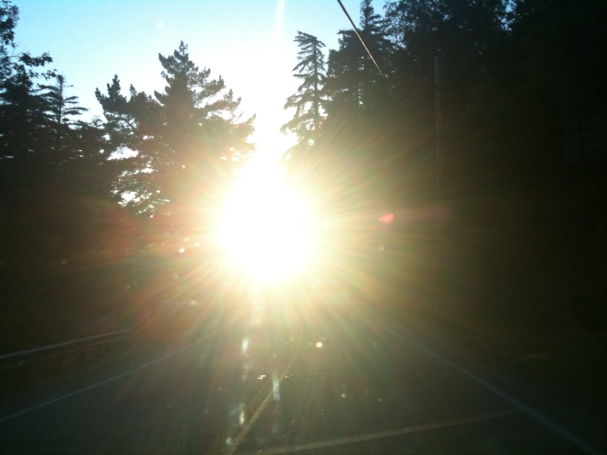
When you think of winter road hazards, snow, hail and rain are the usual suspects. However, bright sun can also be a significant problem for drivers. According to data from the Department for Transport, around 3,900 people are injured in accidents caused by the blinding effects of the sun each year. During the spring and the winter, the low angle of the sun can often mean that your sun visor doesn't actually protect your eyes – a hazard that is particularly acute when the sun reflects off a wet road surface, creating strong, bright glare. Here’s a few steps you can take to improve visibility and keep you from driving blind.

Keep your windscreen clean

Dirty windscreens can make glare significantly worse, as dirt and debris scatter sunlight and lower visibility further. Fully clean your windscreen before starting your journey. Check that both the inside and outside of the glass are clean and free of grease. If your windscreen needs a deeper clean, rinse it with cold water and a soft brush, then follow with glass cleaner. Be careful in the morning following a frosty spell – scraping ice off your windows can sometimes leave smear marks behind.

Windscreen wiper fluid

Throughout the winter months, keep your windscreen wiper fluid topped up, and check your wiper blades for wear and tear by looking for small cracks in the rubber. New wiper blades are fairly inexpensive and easy to fit (usually starting from £9.99 for a set), and it's recommended that you replace your wipers every 12 months.

Wear sunglasses

Although sun visors are helpful in summer, sometimes the angle of the during winter sun is simply too low for them to make any difference. If conditions are bright, try a pair of sunglasses when driving.

Be extra aware of other road users
When driving in low sun, remember that other drivers may also be suffering from the blinding effects of glare, even if you aren't. Try to maintain a constant speed, keeping a safe distance from the vehicle ahead. Avoid any sudden stops and be extra vigilant in the mornings and evenings, when the sun is especially low in the sky


What’s a roundabout? IAM RoadSmart

reveals shocking lack of road knowledge by UK drivers
A survey conducted by the UK’s largest independent road safety charity, IAM RoadSmart, found that many drivers have a real lack of awareness of the rules of the road, putting themselves and others in danger.

More than 50% admitted their road knowledge was so poor, they didn’t recognise the roundabout sign. More than two-thirds of drivers admitted they had no understanding of the two second rule. Over 1,000 motorists participated in the survey for IAM RoadSmart to test their knowledge of the Highway Code.

6

Some 68% of drivers were unaware of the two-second following distance in dry weather, with 53% confusing this for two car lengths. This results in a gap of less than a third of a second when travelling at 60mph, for an average-sized family car. When asked what to do when arriving to a scene of a serious crash, almost half (48%) were unaware that the first thing you need to do is to warn others of the danger by turning on hazard lights.


Of those who participated, over half were not able to identify that a circle shaped sign demonstrates traffic signs that give orders – a crucial piece of information when on the road. Drivers aged 70 onwards statistically scored below average on this question.

Worryingly, two-thirds of those surveyed admitted they were unable to recognise the colour of the reflective studs between a motorway and its slip road, with only one in five (20%) of those aged 17 to 39 answering correctly that they are green.

Neil Greig, IAM RoadSmart director of policy and research, said: “This is truly shocking. The outcome of the survey brings to light some frightening statistics which demonstrates the need to constantly re-fresh on-road knowledge.”

Friendship
is when people know all about you…
but like you anyway !

I don’t like to think before I speak….
I like to be just as surprised
as everyone else about what I say

Group President: Trevor Poxon MBE
Chair: : Martin Goad  120 Hednesford Rd, Brownhills  tel. no. 01543 371516 martingoad@mail.com | Committee Member  Kath Hawker  8 Fallowfield Road, Walsall
Group Secretary:  Josie Hubbard-Palmer  Chief Observer:  To be appointed | Assoc Co-ordinator  Mike Bentley
Treasurer - Karl Spooner  26 Woodside Close, Walsall | Committee Member:  Alison Kimberley
Committee member:  Sarah Harrison  Black Bryony, Grove Basin,  Lime Lane, Pelsall, nr Walsall  Tel.07775-694625 | Newsletter Editor & Minutes Sec  Sandra Wootton  70a Bescot Road, Walsall  Tel:01922 621592  Email: sandrawootton.flowers@gmail.com
Committee Member  Chris Rice | Group Registered Charity no.  1082326
The opinions expressed in this Newsletter, which is published by the Walsall Group of Advanced Motorists, are those of the Editor and individual contributors and do not necessarily represent the views of the Institute of Advanced Motorists Ltd. Data Protection Act: We are obliged by law to inform members that their membership details are held on computer disc. This information is for group administration only. If any member wishes that their details are NOT to be held on computer disc, please inform the Editor forthwith.
7

