

Aldridge Community Centre, on the first Sunday of each month
(unless otherwise stated)
at Middlemore Lane, Aldridge. WS9 8AN, starting at 9.30am on
Sunday 8th January 2017
Sunday 5th February 2017

2016 Committee meetings
These will be on the second Tuesday of the month. Venue:Aldridge Community Centre

Group Contact Details
Committee email: info@wgam.org.uk
The Group website is: www.iamroadsmart.com/groups/walsallam
or contact Newsletter Editor Sandie 01922 621592

A warm welcome to our new Associate
Mohammed Mazar

We wish all our Members, Associates & their families
A VERY HAPPY NEW YEAR
& safe driving in 2017

1


For your 2017 diary
Here are definite items for your diary

New Year meal - Friday 20th January
At Calderfields Golf Club, Aldridge Rd, Walsall WS4 2JS. 7pm for 7.30pm.
The menu is varied, (for example ) main dishes vary from Roast of the Day for £8.50 to Sirloin Steak £18.95, with all the trimmings. Karl will also be sending out an email with details of this meal.
Contact Martin on martingoad@mail.com if you are planning to attend events, particularly the meals.

Tuesday 21st February
We are having a talk by a local examiner, Steve Tyler, on the system of car control. Venue: Aldridge Community Centre. Time: 8pm

Saturday 8th April
We are holding a Long Service recognition afternoon tea at Calderfields Golf Club.

Tuesday 25th April: It’s our Annual General meeting - a date not to be missed

Now for suggestions from our events sub-group:
→ May Bank Holiday (1st May):
A drive and get together at a venue for lunch
→ June:
A visit to the National Traffic Control Centre, Quinton, Birmingham
→ July: A treasure hunt

However ………..
If you have any ideas for visits, events, or talks please do let us know or better still come and join us on the events sub-group. Have we visited somewhere and you would like to go again ? You don’t have to be a member of the group committee. All ideas are VERY gratefully received.


Martin Goad’s CHAIRMAN’S CHAT
As I write this, Winter seems to have really arrived at last. There is a thick frost on the roads and on the car, so it takes an extra ten minutes of scraping and spraying to get the windows clear before setting off on the first drive of the day. However we are past the shortest day and can look forward to the increasing hours of daylight which seem to lift the spirits a bit and make life a little less difficult.

I drive a Focus and one of the benefits of a Ford is the heated front windscreen which makes light work of even the heaviest layer of ice. My wife`s Mondeo is great on a frosty morning and the screen is clear in no time, but the first owner of my car decided, in their wisdom, to not order the heated screen but opt for cruise control instead. Now I do like cruise control and use it often and all year round, but at this time of year I would really, really like the heated front screen.

2

CHAIRMAN’S CHAT continued…
As the days get noticeably longer and we start to feel like getting out more I would like to draw your attention to the events programme for the next few months. We would love to see as many of you as possible at the Winter Meal on 20th January. On the evening of 21st February at 8pm at Aldridge Community Centre we have a talk on The System of Car Control by local examiner Steve Tyler which promises to be very interesting.

We are planning an afternoon tea at Calderfields Golf Club in April to celebrate the long service of several of our members. Later in the year we are planning a drive to a late spring lunch, a visit to the National Traffic Control Centre, another Treasure Hunt after last year`s successful one and a quiz with a fish and chip supper in the Autumn. If there are events or talks that are not on the list that you would like to suggest, then please let me know. I hope to see you at as many as possible this year.

Well we still have a couple of months of Winter on the roads, so take care out there and enjoy the bright, crisp days while they last.

Are you going to treat yourself in 2017 ???

Are you thinking of buying a new car in 2017 –

here is some advice from the DVLA

New vehicle tax rates
The way vehicle tax is calculated will change for cars and some motor homes that are first registered with DVLA from 1 April 2017. Here is what you need to know if you’re thinking about buying a new vehicle. You’ are not affected if your vehicle was registered before 1 April 2017 - check your vehicle tax rate to find out how much you’ will need to pay.

The new rates

The amount you pay the first time you tax your vehicle is based on CO2 emissions. Check the vehicle tax rate tables to find out how much you need to pay. The amount you pay the second time you tax the vehicle depends on the type of vehicle.

You will pay:
- £140 a year for normal petrol or diesel vehicles
- £130 a year for alternative fuel vehicles (hybrids, bi-ethanol and LPG)
- £0 a year for vehicles with zero CO2 emissions
(Now, attention everyone, is this all perfectly clear !!!!)

New vehicles that cost more than £40,000 (you should be SO lucky)

If you buy a vehicle with a list price (the published price before any discounts) of more than £40,000, you’ll pay a rate based on CO2 emissions the first time it’s taxed. When you tax it for the second time you’ll pay one of the new rates (depending on the vehicle) and an additional rate of £310 a year for the next 5 years. After 5 years, your vehicle will then be taxed at one of the new rates again. Check the list with your dealer so you know how much vehicle tax you’ll have to pay.

Know your vehicle tax rate: You can check the tax rates for all vehicles if you’re thinking about buying a new or used vehicle. You can also apply for discount on your vehicle tax if you claim certain benefits.
3

Did you know ……..

Useful advice for parents & Grandparents

Booster seats
Backless booster seats, which are sometimes referred to as ‘booster cushions’, seeking certification for sale in Great Britain must be labelled to restrict their use to children who are taller than 125cm and weigh more than 22kg. However, the new regulations will only apply to new products entering the market and won’t be applied retrospectively to products already in circulation and being used by parents, grandparents and carers. The ban was originally expected to come into force in December 2016, but it isn’t now expected to become law until March 2017.

Talk by Mike Kelly
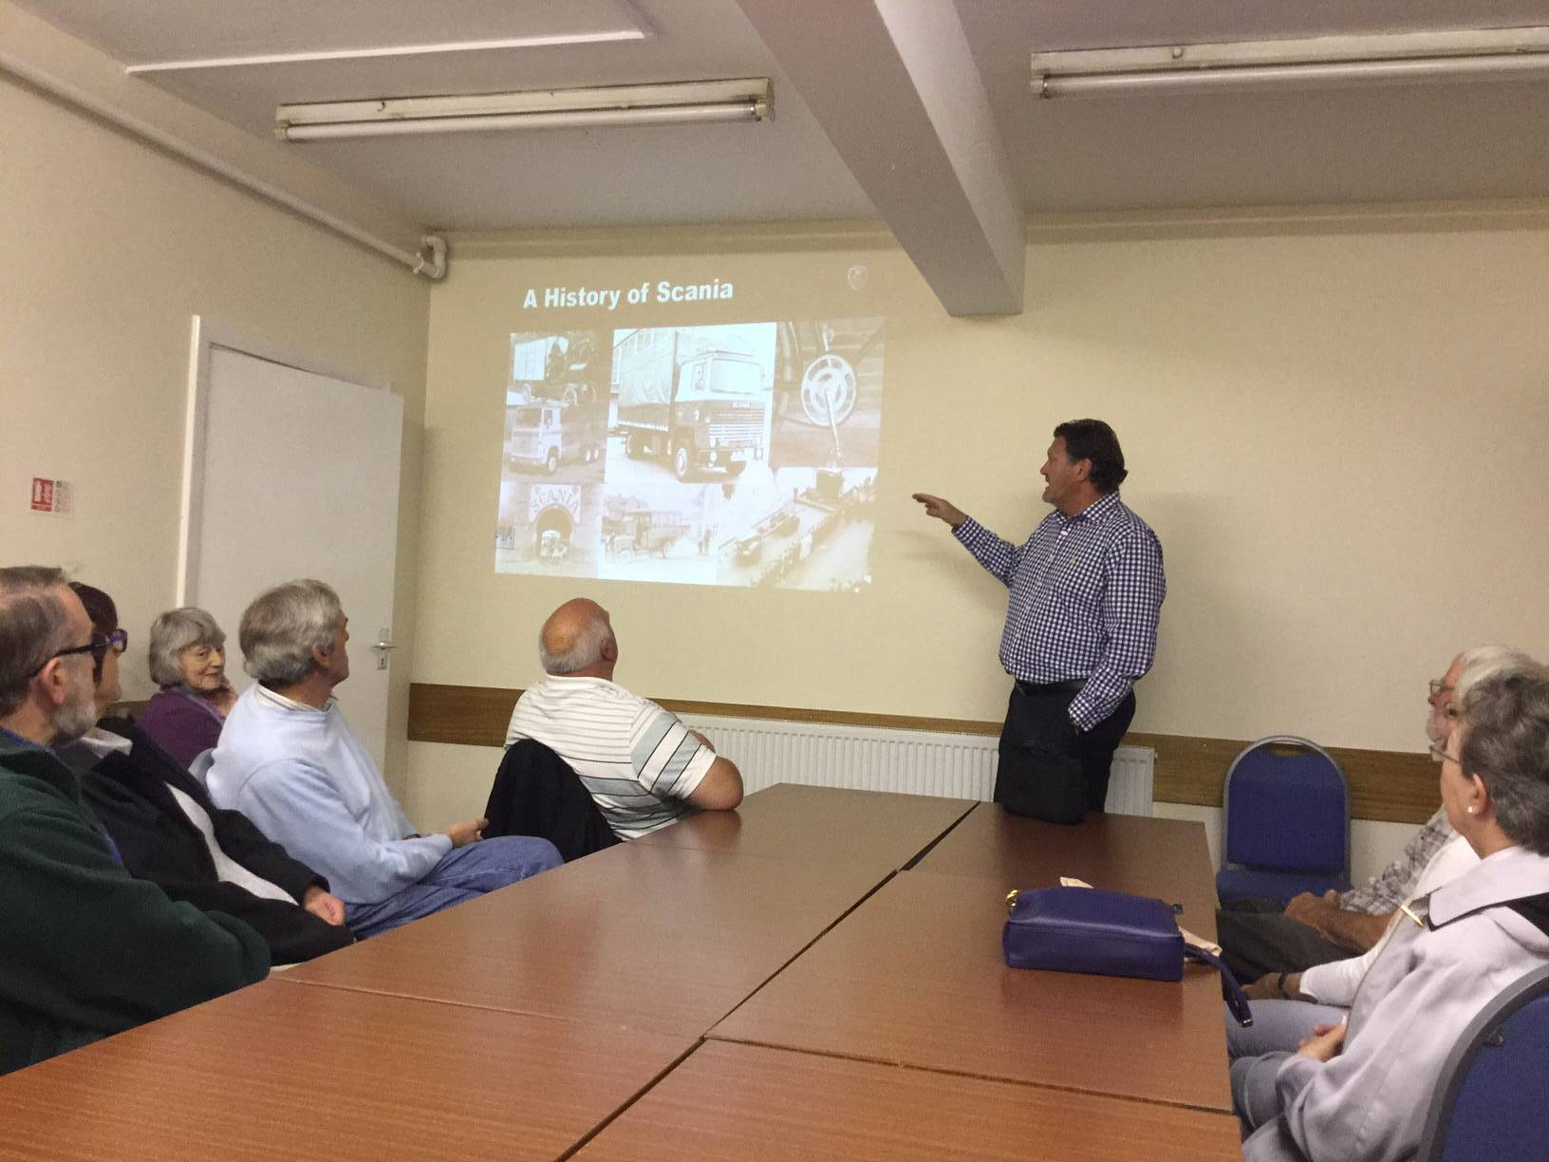
Mike is a longstanding member of the group who is a Director of Keltrucks. He came along to Aldridge Community Centre on Tuesday 25th October with his daughter Ria, to tell us about the business and some of the aspects of heavy goods vehicles on our roads. Many of you will have seen the Keltrucks Scania dealership just beside the M5 at West Bromwich, but Mike told us of the other branches across the UK and their strong link with Scania in Sweden.

It was really interesting to hear about the variety of trucks on the roads and about how hard they are put to work compared to the cars and bikes that most of us use. We think that 100,000 miles is a decent mileage in the life of a car, but for an HGV it might only be a year or so of use. So clearly the business of selling and maintaining trucks to keep them working is vital to the transport industry and so important for the running of the economy.

4

Talk by Mike Kelly
Once Mike had given his presentation the question came thick and fast as he had got us thinking about a different aspect of road usage that most of us know only a little about. He has a fund of knowledge from years of experience in the business so was able to deal easily with all we threw at him. It was great to have one of our own members giving us the benefit of his knowledge and we owe a big thank you to Mike and Ria for their time and his presentation. Thank you again.

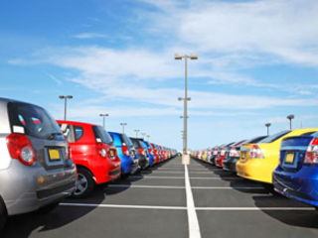
HOW SAFE IS YOUR CAR ON A
SUPERMARKET CAR PARK?
Two in 3 British motorists say they have come back to a damaged car after leaving their motor in a car park – and many have experienced damage multiple times. Just 9% say the person who damaged their car owned up and left a note. Such car park damage is usually minor, but not cheap to fix. Around four in 10 people reported the damage was golf ball-sized; for a fifth, it was tennis ball-sized. An unfortunate 8% say it was football-sized. The most common place to suffer car park prangs is supermarket car parks. Almost half of respondents to a survey say they’ve had a car scratched or dented there.

Although the vast majority of people who damage someone else’s car don’t leave a note, this is no surprise to around four in 10 respondents. “They wouldn’t expect anyone to do the right thing and leave a note these days,” they say. Even so, just under half were disappointed the other person didn’t leave their details. Most people don’t claim on their insurance for such damage either, usually through fear of losing their no-claims bonus.

So how can we avoid it?
1. Ensure that you park centrally in the space, within the white lines and as straight as possible.
2. Reverse into parking spaces – it gives you greater control and it will be easier to get out of the space safely.
3. Look for spaces at the end of a row and any wider spaces that offer more room.
4. If a space is tight, fold in your wing mirrors.
5. Steer clear of the trolley park in supermarket cars parks.
6. Always open your doors slowly and carefully.
7. Encourage your children to pay attention to the vehicles around them when entering and exiting a vehicle.
8. Try to park next to cars that are in good condition, as they tend to have more careful owners.
9. If you’re courteous and considerate to other drivers, hopefully they will treat you in a similar way.

10. If you are worried the gap is too small, it might be best to take a couple of extra minutes and try to find a wider space.
And finally a tip from Editor Sandie:
Park as far away from the supermarket entrance as possible, well away from other cars!!! There are usually plenty of spaces at the far end of the supermarket car park. The extra exercise will do you good (Unless of course you have a mobility problem).
However, even when you do try to park further away some other driver will come and find you and park immediately next to you, not a few spaces away, NO immediately next to you, as if they are lonely !!!
5


We don’t seem to have snow in the winter now
but lots of heavy rain, so here is some
ADVICE FROM THE HIGHWAYS AGENCY
WHEN IT RAINS

Drivers are being urged to slow down when it’s raining after almost 3,000 people were killed or seriously injured when driving in the rain last year.

Highways England is launching a new safety campaign warning drivers that ‘when it rains, it kills’ after the latest statistics showed that people are 30 times more likely to be killed or seriously injured on the roads in rain than in snow. The figures also reveal that travelling too fast for the current conditions was identified as a factor in 1 in 9 road deaths in Great Britain last year, with drivers failing to alter how they drive in response to changing conditions on the road.

Highways England is warning that even driving within the speed limit in wet weather could be dangerous if drivers don’t allow extra space between them and the vehicle in front. And the message is being reinforced with rain-activated paint messages visible to people leaving motorway services when it is raining. Most of us already slow down in snow, ice or fog but when it rains we consider it normal so don’t adapt our driving.

The sad fact is that 2,918 people were killed or seriously injured on the roads when it was raining last year, and not slowing down to suit the current conditions was identified as a factor in 1 in 9 of all road deaths.

Rain makes it harder for tyres to grip the road and harder for drivers to see ahead – significantly increasing the chances of being involved in a collision. We’ve launched our new campaign to make drivers aware of the dangers and to stay safe. It generally takes at least twice as long to stop on a wet road as on a dry road because tyres have less grip on the surface. In wet weather you should:

→ Slow down if the rain and spray from vehicles is making it difficult to see and be seen
→ Keep well back from the vehicle in front as this will increase your ability to see and plan ahead.
→ Ease off the accelerator and slow down gradually if the steering becomes unresponsive as it probably means that water is preventing the tyres from gripping the road.

In total, 197 people lost their lives on roads during rainfall in Great Britain last year and 2,721 suffered a serious injury, compared to 14 deaths and 153 serious injuries during fog, and 2 deaths and 95 serious injuries during snow. Highways England is aiming to reduce the number of people killed or seriously injured on England’s motorways and major A roads by 40% by 2020 through road improvements, safety campaigns and other initiatives.

General enquiries: Members of the public should contact the Highways England customer contact centre on 0300 123 5000

6

And finally (what you have been waiting for !)

The nothing to do with motoring bit

New Year Resolutions - but why?
New Year is about making promises and making resolutions to do better in life. New Year is all about newness. It is celebrated on the 1st of January every year marking a start of yet another New Year. There are many resolutions that people make commonly on the New Year eve. The most common and top rated resolution that almost every person takes is to work out and stay fit.

Here’s some suggestions how to achieve your goal in 2017:
☺ Take some time and think about the last year resolution made by you. Have you stood by them? If not, better don’t make any new resolution and try to accomplish the incomplete resolution.

☺ Make A Realistic Resolution: Many people make resolution which appear great on paper or while speaking. However, they are extremely difficult to accomplish. Avoid those kind of resolution. Instead, try to make resolution which you can accomplish.

And a few words of wisdom to finish !!!
☺ I would say happy new year but it’s not happy; it’s exactly the same as last year except colder.
☺ Tomorrow is the first blank page of a 365 page book. Write a good one
☺ May each and every day of yours be renewed with lots of happiness and love. Happy New Year.
☺ As the New Year dawns, I hope it is filled with the promises of a brighter tomorrow.
HAPPY NEW YEAR

Group President: Trevor Poxon MBE
Chair: : Martin Goad  120 Hednesford Rd, Brownhills.  01543 371516 Email: martingoad@mail.com | Committee Member - Ann Humble  253 Bosty Lane, Aldridge, Walsall . 01922 454800
Group Secretary: Glynnis Jeavons  44 Goscote Road, Pelsall 01922 691053. | Committee Member: Kath Hawker  8 Fallowfield Road, Walsall. 01922 62245
Treasurer - Karl Spooner  26 Woodside Close, Walsall 0121 357 4356 | Committee Member: Paul Honeghan  Committee Member: Alison Kimberley
Assoc Co-ordinator Clive Allsop  10 Lake Avenue, Walsall 01922 – 628339 | Co-opted Members:  Josie Hubbard-Palmer  Peter Browne
Chief Observer & Committee member:  Sarah Harrison  Black Bryony, Grove Basin,  Lime Lane, Pelsall, nr Walsall 07775-694625 | Newsletter Editor & Minutes Sec  Sandra Wootton  70a Bescot Road, Walsall 01922 621592  email@sandrawootton.flowers@gmail.com
 | Group Registered Charity no. 1082326
The opinions expressed in this Newsletter, which is published by the Walsall Group of Advanced Motorists, are those of the Editor and individual contributors and do not necessarily represent the views of the Institute of Advanced Motorists Ltd. Data Protection Act: We are obliged by law to inform members that their membership details are held on computer disc. This information is for group administration only. If any member wishes that their details are NOT to be held on computer disc, please inform the Editor forthwith.
7

