

Aldridge Community Centre, on the
first Sunday of each month (unless otherwise stated)
at Middlemore Lane, Aldridge. WS9 8AN. Starting at 9.30am on
Sunday 2nd July
Sunday 6th August
Sunday 3rd September

2017 Committee meetings
These will be on the second Tuesday of the month. Venue: Aldridge Community Centre

Group Contact Details
Committee email: info@wgam.org.uk
The Group web site is www.iamroadsmart.com/groups/walsallam
or contact Newsletter Editor Sandie 01922 621592

For your 2017 diary
Dear Reader
We are having a stand at the following events. If any of you have an hour to spare to help then please do let us know. No hard work – just giving out leaflets and chatting to interested people. The event times are between 10am & 4pm and the dates are
Aldridge Show – 24th June
Pelsall Carnival - 8th July
Walsall Fire Station – 12th August
September:
Treasure Hunt. Sunday 3rd September . Starting from Aldridge Community Centre at 1.30pm – 4pm. M&S voucher for first prize. This is the second year Sarah and Ann have organised the treasure hunt. From all reports, last year was a brilliant event.

October:
Quiz Night / Fish & Chip supper. Tuesday 17th October 7.15pm for 7.30pm start. Venue – Aldridge Community Centre. It’s a general knowledge quiz (not motoring based). We will need to know if you are coming all so we can order the fish & chips. There is a cost but it won’t break the bank (abouts £5) but I will let you know precisely how much next edition.

Autumn:
Talk about crash investigation and the effects on humans. Date to be finalised - but one for your diary.

1


A Warm to our new Associates

Mr Duncan Greig
Mr Andrew Hill
Mr Alexander Lees
Martin Goad’s

As I was driving on my regular route from Brownhills to Willenhall this week I was thinking about the delights of Summer driving. There was a steady drizzle and the outside temperature registered 13 centigrade, I had my lights on and the aircon to keep the screen clear of mist. A week before it was 30 degrees and wall to wall sunshine. Ah the British Summer!

My thoughts went back to when I was young and my parents got their first car. We went out most weekends in the Summer just for a drive and it was great fun. We had a Morris Minor 1000 which we shared with my aunt and uncle. Dad could get it up to 60 MPH on the open road when Mother was being distracted by my younger brothers playing up on the backseat (not me of course). We often took a picnic and set out towards the Surrey countryside with no specific destination in mind, but just to drive and explore. On high days we would go down to the seaside for the day. Of course the sun always shone and we never had a cross word between us!

Apart from our biker friends and those with specialist cars such as MGs, we seem to have lost the joy of Summer driving. Our driving tends to be functional to get us to a place where we need to be to do something else. Often the drive is not much fun as the roads are busy and we get delayed. Certainly traffic has increased out of all proportion since those heady days in the 1960s when I was going out with my parents. Cars are much better now, full of modern conveniences and normally so reliable. Back then we expected to break down from time to time, but also we expected to be able to fix the problem on the roadside ourselves mostly.

In the Driving magazine from the IAM and in the press from time to time there are great drives highlighted. Routes to do just for the joy of it. An outstanding feature of any of these routes is that they are away from the busiest trunk roads and big conurbations.

Last year, in my piece for this newsletter, I suggested trying to get off the motorway and find a route along A and B roads even for a long journey because the traffic is likely to be lighter and the drive is more stimulating. Admittedly these routes might take longer, but not always.

It is worth trying driving just for the sake of it. One thing we used to do going back, was treasure hunts. Last year we re-introduced the idea and the event that Ann and Sarah organised was great fun. They are doing another on the Sunday of the September drive in the afternoon. Give it a try, it could be one way back to driving for fun, there is that word again FUN.
2

Congratulations on passing
your test to

Kieran Forde
Date: 22nd May Observer: Phil Gough
David Judd
Date: 4th June Observer: Josie Hubbard-Palmer
Ray Fisher
Date: 17th June Observer: Mike Bentley
Nigel Palmer
Date: 18th May Observer: Mike Bentley
AND
Well done to Paul Honeghan who took his his National Observer test in May and passed flying colours. The examiner Steve Ellis came from Doncaster, and was very impressed with the standard of Paul’s driving and observing. His scenario was dual-car ridgeways and motorways. He liked the fact that Paul used new technology to show him the route that they were going to drive
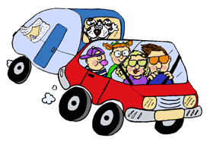

Checks before you tow
Carry out basic safety checks to make sure that your vehicle and trailer are safe and legal. You can be fined up to £2,500, be banned from driving, and get 3 penalty points for using a vehicle in a dangerous condition.

Tow ball and connections - Check that:
- the trailer is correctly coupled to the towball or pin - follow the manufacturer’s advice
- the coupling height is correct
- the 7 or 13 core cable and plug isn’t damaged

Breakaway cable
Use a breakaway cable or secondary coupling. This engages the trailer’s brakes (if fitted) or stops the trailer if it becomes detached from the car. Check that:
- The cable isn’t worn or damaged
- There’s enough slack in the cable so that it doesn’t accidentally apply the brakes
- The cable won’t drag on the ground when you’re driving. Follow the manufacturer’s advice to make sure it’s connected correctly.

Wheels & tyres - Check the tyres on both the car and trailer:
- Don’t have any cuts or bulges
- Are inflated to the manufacturer’s specification for the load being carried
- Check that each tyre has a tread depth of at least 1.6mm:
- Across the central three-quarters of the breadth of the tread
- Around the entire circumference of the tyre
- Check that the wheel nuts and bolts are tightened to the correct torque.
- Check that mudguards are fitted to the trailer and they’re secure.

Lights and indicators
Check that there’s no damage to the lights, and that they’re all working correctly.
3

Load and weight limit - Check that:
- the trailer isn’t overloaded
- the load is distributed evenly
- the load is secure

Dear reader - did you know ????

The DVLA tells us that:

You should check your number plate or face £1,000 fine. UK motorists driving around with a dirty car could land a £1,000 fine - this is why.
It’s inevitable that cars are going to get grimy, dirty and dusty. However, British drivers have a responsibility to keep their vehicle clean or they could risk landing a hefty fine. If this dirt or grime builds up so much on the car’s number plate, to the point where it becomes unreadable, you are committing a driving offence.
The Government clarifies the legal position as follows: Number plates (also known as licence plates) should show your vehicle registration number correctly. You can't rearrange letters or numbers, or alter them so that they're hard to read. The fine for driving a car with an unreadable number plate is now up to £1,000. In addition, it is enough of an offence for a car to fail its MOT. There is a specific offence under the Vehicle Excise and Registration Act 1994 of obscuring or allowing a registration mark to be not easily distinguishable. All registration numbers must be displayed clearly and correctly on the number plate – this helps the police, enforcement agencies and members of the public to correctly identify a vehicle to assist road safety and traffic enforcement.

So, what at the legal requirements of a number plate:

It should be made from a reflective material

Display black characters on a white background (front plate)

Display black characters on a yellow background (rear plate)

Not have a background pattern

If you ride a motorbike or motor tricycle
Motorcycles and motor tricycles registered on or after 1 September 2001 must only display a number plate at the rear of the vehicle.

Towing a trailer
Your trailer must display the same number plate as the car you’re towing it with. If you’re towing more than one trailer, the number plate must be fixed to the trailer at the back.

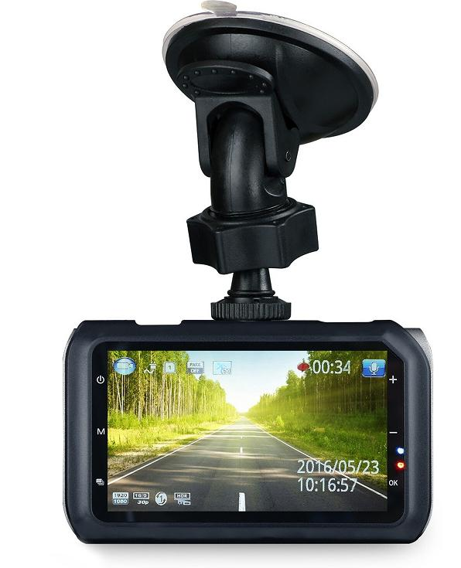
DASH CAMS
MOTORISTS owning and using dash cams have become prolific over the past few years but there are some rules every user should know. UK drivers are reaping the benefits of the cameras using them to protect themselves in the case of an accident. Additionally, it was recently revealed that dash cams can shave up to 20 per cent off your car insurance bill. They also catch those jaw dropping moment such as this motorist got stuck up a tree after it rolled backwards on a motorway when an elderly motorist allegedly almost got carjacked.
4

Despite the many benefits of the camera for safety and saving cash, drivers can also get into trouble for using these cameras in certain countries. If drivers are preparing to go abroad in their car with their camera to be aware of the restrictions certain countries impose. In certain countries there are certain laws and bans in place preventing drivers for using these cameras. Austria and Luxembourg have known bans for drivers using these cameras while another list of countries have restrictions.

Dash cams are currently legal in the UK but drivers need to make sure the the camera does not obstruct the driver’s view. Also, because dash cams have not been designed to invade a person’s privacy, there is no “reasonable exception of privacy” on public roads.

(Dear Reader - I’ve recently received a Dash Cam as a birthday present. I will be ok once I’ve figured out how to work it !!! I’m sure it will be very useful ! Editor Sandie)

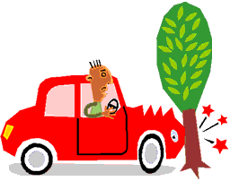
TIPS FROM THE IAM

Reducing your insurance costs

Securing the right motor insurance is an unavoidable headache, but once you have it can be off-putting hearing about the many ways you could have saved or reduced your monthly payments. These tips give advice on reducing your motor insurance costs.

- Take an advanced driving course. Most insurers recognise these courses and may offer a discount
- Shop around when renewing your insurance, it’s the best way make sure you are getting the best deal
- Consider downsizing. Buying expensive cars such as a 4x4 or an exotic sports model may seem like the dream but the insurance is much more expensive as opposed to insuring a less luxurious car which will be expensive to repair. Cars are insurance rated from 1-50 and the lower the better if you want to contain costs
- Location plays an important part in determining your insurance rate. If you are planning to move, a potential shift in your postcode can effect your car insurance rate and is something you should consider in your budget
- Changing the amount of excess you would pay in the event of a claim can make a difference to your yearly premium- make sure you are happy with the excess amount though
- Stay away from car modifications. A lot of the time you see many young drivers modifying their alloy wheels, body kits etc. This is something that you must try to avoid as they are known to increase premiums. If you are keen to modify your vehicle always inform your insurer.
- Consider using a telematics-based black box policy. Mainly available for younger drivers many insurers are now offering mobile phone based apps for all drivers. These devices monitor car usage and driving behaviour and set your premiums based on your actual driving performance.

Insurance is a motoring essential but shopping around has never been easier. Insurance companies now share data on crash history so it never pays to be economical with the truth. Postcode, driving history, insurance rating and driver age will always be the main way to set premiums but follow our simple tips and you can make savings.

5

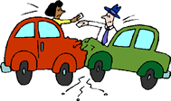
More Tips from the IAM:

The aftermath of an accident
After being involved in a road traffic incident it is easy to lose confidence and the thought of getting back in the driving seat can be quite daunting.

- Take your time - there is no rush to get back behind the wheel- it is not something you should feel pressured into doing. It is important to be in the right state of mind and be confident of your ability behind the wheel.

- Everyone is different but think carefully before you change your driving patterns to avoid the crash site. Changing your route to avoid where the incident occurred isn’t always productive and may not help you – it could even escalate the issue.

- When you first get back in the car consider taking another person with you for support. If your confidence has been seriously affected engage the assistance of a professional.

- If the concern is affecting you in your daily life, consider seeking help form your GP. A post incident intervention course from a provider such as IAM RoadSmart can be a good option to help restore confidence and allay fears. If you are worried and you notice it is stopping you from doing your normal activities, we recommend getting in touch with your GP.

- Remember road traffic incidents happen all too frequently; the important thing is to understand what happened, learn from it where you can and then move forward and start enjoying your driving again.

- Even a minor collision can play on your mind but it is important to learn from the experience. A major part in the human factors around driving is the ability to self-evaluate your driving and make a conscious decision to improve.

- A collision where we have to accept some or all of the blame should be taken as an opportunity learn and improve. Recognising that help is needed is a major step to asking for it.

And as it’s summer here’s some useful advice
on getting prepared for the great escape
Going away during the summer is something that many look forward to. Prevention is better than cure and if you are taking your own vehicle abroad it is a great idea to be prepared for the unexpected events that can occur when on the road.
- Make sure you have the right insurance and breakdown cover. In an event of a breakdown you want to make sure you have international coverage and also know what numbers and companies you have to get in touch with.

- If possible do not go at it alone. It is better to have two drivers who can take turns to avoid fatigue. On a family trip children can appreciate a bit of attention how about taking a turn in the back. Give yourself plenty of time and don’t set unrealistic deadlines to catch ferries or to arrive at your accommodation.
6

- Plan your journey. If you know you are going to be doing a few trips in it is better to know the road and not rely on sat nav’s.Some sat nav’s do not function internationally and unless you have a lot of data it can be costly using your phone as a navigation system. In some countries sat navs with speed camera information in them are illegal.How about going old school and investing in a new map to plan your journey out, if the technology lets you down at least you have a back up.

- Make sure you have the right documentation. We recommend taking your full driving licence, your insurance documents, both the car and travel documents, you vehicle registration certificate and lastly European Health Insurance Cards and passports, dependent on your destination

- Don’t drink and drive or break local speed limits as fines can be issued on the spot in some countries and the exchange of information between police forces is now common place so your misdemeanours may follow you home

And finally
Check your motor before you leave. If you are not up to date with your car servicing go in for a full service to avoid any hiccups whilst travelling.

and finally –
the nothing to do with motoring page
thanks to Shirley !!!

ATTORNEY: Doctor, how many of your autopsies have you performed on dead people?
WITNESS: All of them. The live ones put up too much of a fight.
-------------------------

ATTORNEY: Do you recall the time that you examined the body?
WITNESS: The autopsy started around 8:30 PM
ATTORNEY: And Mr. Denton was dead at the time?
WITNESS: If not, he was by the time I finished.
---------------------------
And the last one!
ATTORNEY: Doctor, before you performed the autopsy, did you check for a pulse?
WITNESS: No.
ATTORNEY: Did you check for blood pressure?
WITNESS: No.
ATTORNEY: Did you check for breathing?
WITNESS: No.
ATTORNEY So, then it is possible that the patient was alive when you began the autopsy?
WITNESS: No.
ATTORNEY: How can you be so sure, Doctor?
WITNESS: Because his brain was sitting on my desk in a jar

7

Group President: Trevor Poxon MBE
Chair: : Martin Goad  120 Hednesford Rd, Brownhills.  01543 371516 Email: martingoad@mail.com | Committee Member: Kath Hawker  8 Fallowfield Road, Walsall. 01922 62245
Group Secretary: Josie Hubbard-Palmer | Committee Member - Gill Essex
Treasurer - Karl Spooner  26 Woodside Close, Walsall 0121 357 4356 | Committee Member: Paul Honeghan
Chief Observer & Committee member:  Sarah Harrison  Black Bryony, Grove Basin, Lime Lane, Pelsall, nr Walsall 07775-694625 | Committee Member: Alison Kimberley  Co-opted Members: Peter Browne
Assoc Co-ordinator: To be appointed  Committee Member: Chris Rice | Newsletter Editor & Minutes Secretary  Sandra Wootton  70a Bescot Road, Walsall 01922 621592  email@sandrawootton.flowers@gmail.com
 | Group Registered Charity no. 1082326
The opinions expressed in this Newsletter, which is published by the Walsall Group of Advanced Motorists, are those of the Editor and individual contributors and do not necessarily represent the views of the Institute of Advanced Motorists Ltd. Data Protection Act: We are obliged by law to inform members that their membership details are held on computer disc. This information is for group administration only. If any member wishes that their details are NOT to be held on computer disc, please inform the Editor forthwith.
8

