


At Aldridge Community Centre, on the
first Sunday of each month (unless otherwise stated)
at Middlemore Lane, Aldridge. Starting at 9.30am on
Sunday 3rd July
Sunday 7th August
Sunday 4th September
Sunday 2nd October
Sunday 6th November
Sunday 4th December

2016 Committee meetings
These will be on the third Tuesday of the month. Venue: Aldridge Community Centre

to
Malcolm Woodyatt
On Sunday 12th June. Observer: Martin Goad. Senior Observer: Simon Arnold

Margaret Rowntree
Alan Barnett
Oli Rose

Group Contact Details
Committee email: wgamcommittee@yahoo.co.uk
The Group website is: jeavonsge@yahoo.co.uk
Or contact Newsletter Editor Sandie 01922 621592

1

to
Kath Hawker
Clive Allsopp
We are missing you both on the committee

News from our recent AGM:
We had a collection for the Blood Bikers Group, who were our guest speakers at the AGM back in April. We are pleased to report an impressive amount of £75 was raised to assist their charitywith its vital work. Well done everyone.


from Martin Goad

We have had two events this spring - a visit to Drayton Mercedes in Walsall and a visit to the Aston Manor Road Transport Museum in Aldridge, where it was great to see a good number of members, partners and friends enjoying themselves and learning something new.

We are arranging some events for the summer and autumn, a meal, a treasure hunt and a talk on drinking/driving awareness, so please have a look in the newsletter for details and please come along and join in.

It was good to see a couple of new faces at the last Sunday run, new associates are the life blood of the group.

By the time you read this we will have been to Aldridge Summer Fayre and Pelsall Carnival with our gazebo and our leaflets to raise our local profile and hopefully to attract new members. The best publicity is always word of mouth from our members to their friends, family and workmates, so please keep on putting our road-safety message out there.

One way that all members can help to promote the IAM is, when you have read it, to put your copy of Driving magazine in a place where the general public can see it, maybe in the doctors waiting room, the library, the community centre or in a car dealership (but please do ask first of course).

I hope that you all have a safe and enjoyable summer of driving
(when and if it ever stops raining !!!! Editor Sandie)

2

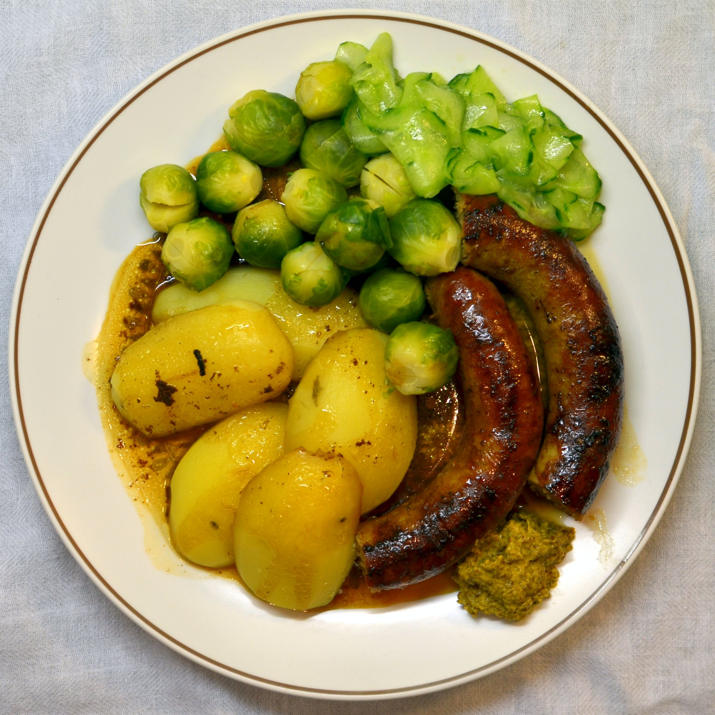
Forthcoming events

Summer Meal
23rd August, The Boat restaurant. 7pm for 7.15pm start.
Here’s your chance for an evening out - we have, so far, booked a table for 12 people. The menu is a good range, with an extensive choice from the ‘specials’ blackboard. We have visited this restaurant before and a very good time was enjoyed by all. The address is Oddfellows in The Boat, Walsall Road, Summerhill, near Muckley Corner, Lichfield WS14 OBU.

Do you want to attend this emeal? Then contact either Glynnis Jeavons or Editor Sandie - information on the back cover, or of course tell Glynnis or Martin Goad at the next Sunday drives session.


Treasure Hunt - Sunday 4th September,
- Starts from Aldridge CA at 2pm,
- 10 cars only allowed,
- Route approx 2 hours,
- No entry fee.
- The Finish – can’t tell you that !!!
There is a prize of £20 M&S gift vouchers.
Interested: contact Ann Humble on johnhumble1942@gmail.com

Autumn talk - Tuesday 13th September
Jill Wilson will be giving us a talk on drink /driver awareness.
Date Tuesday 13th September. Starts at 7.30pm. Venue: Aldridge CA


Your copies of the Advanced Driving Magazine
Help us to advertise Walsall Group to prospective new associates by letting us have your used copies of the Advanced Driving magazine. We will add a label to the front cover of the magazine advertising contact details for the Walsall Group and leave them in prominent places, i.e. car dealerships, waiting areas, any location where magazines are read by the general public.

If you know of any appropriate locations suitable for leaving your magazine please give me a call and I will let you have a label to add to the front cover. Alternatively, please drop your magazines off to a committee member at one of the Sunday Drives or call Glynnis Jeavons on 01922 691352 to arrange collection.

I am sure, reading the Advanced Driving magazine would help to attractive new members and would provide a clearer idea of what IAM is all about. Do your bit to help us attract new members to Walsall group.
Thanking you in anticipation
Glynnis Jeavons - Group Secretary

3

Visit to Aston Manor Transport Museum
We were all very impressed with our visit to the Aston Manor Road Transport museum in Aldridge last month. Several of our members were not aware of the museum and were surprised to find that it is so close to Aldridge centre.

The first stop was in the classroom where the Chairman of the Museum told us about its beginnings in Birmingham, soon after the last trams completed their final journey when some enthusiasts decided that it was important to conserve our transport history. It is primarily a collection of buses, but other forms of commercial vehicles are also displayed – and there is an E type Jaguar there too.

As with so many of these institutions, it is run by a team of enthusiastic volunteers, who keep the museum running, while keeping up with maintaining the museum and exhibits and restoring new acquisitions. These are being added all the time as old models go out of use. So if there is a possibility of obtaining an example of the type, it will be added to the collection

As ours was an evening visit, there was no possibility of having a ride out but there are regular weekend openings, when vintage buses run trips around Aldridge, to Walsall and beyond. I feel great admiration for all that the team of volunteers have achieved . So if you have not yet visited, I recommend you do, as I am sure you will have an enjoyable time. Their efforts are well worth supporting. The Museum in Shenstone Drive, off Northgate, Aldridge is open on Tuesdays, Saturdays, Sundays and Bank Holiday Mondays. Their website is: www.amrtm.

(Dear Reader – did you miss out on this visit? We could organise it again – if there is enough interest. Please do let us know. Editor Sandie)

We recently asked our members to let us know the reasons why they joined the Group (and the IAM). Here are a few replies …………
☺ Hi. I got my advanced certificate last year and am really pleased that I made the effort to do it. Initially I was attracted to do this as I am getting older and just wanted to ensure I was still safe on the road! Also, I'm sure that eventually the Government will want people over 70 to retake their driving rest, so I wanted to get there before them.

I have senior travel and rail pass so I naturally take advantage of these and have been doing so for some time. Over time this can lead to less confident driving. Additionally I am aware that we can all slip into poor driving habits. A review of the Highway Code is another reason to go for the Advanced Driving Test.

I was told by a friend who had the Advanced Certificate of the Walsall IAM and as I live close to the Aldridge Community Centre it was easy for me to attend the meetings and summer drives at Oak Park. I found the Associate drivers extremely helpful and kind. I now drive with more confidence and have even bought a new car to celebrate !

☺ Morning. I was pestered by Mike Bentley until I joined !!!

4

Why did you join the Group (and the IAM) continued…..
☺ I saw the IAM stand some years ago at the Aldridge Fair. Having driven some 2,000,000 miles, being on the road almost all my working life, both in this country and in Europe, I felt that it would be worth taking the advanced driving test, for I felt sure that some bad habits, inadvertently, had crept in over the years. This mileage is relatively little compared with lorry-drivers and coach-drivers, but it is still significant.

The help given by observers was very illuminating, and it taught me to be more observant, among other things. Subsequently I passed the advanced driving test, and now tend to observe the driving habits of those I go out with. A major one is driving with one hand, so should there be a blow-out or similar loss of control, it could mean disaster. The tendency to pass comment has to be resisted, for men do not like criticism of their driving, so, I “bite my tongue”!!!

Thanks to all those who put up with me during the learning process.

The main reason for signing up to IAM was that I had come increasingly aware that my driving skills had deteriorated over the years and, being newly retired, I now had the time to do something about it. There was little choice with which Group, being so local. (Coming across a voucher for £10 on Ebay was pure coincidence! )


It’s summer (?)
Advice from the IAM on coping with Hay Fever
A runny nose, headache and constant sneezing – these are just a few of the symptoms hay fever sufferers deal with during the summer. These symptoms can affect motorists in a number of ways. Here’s some advice about what you can do to better cope with it before taking to the road.

- Try to minimise the effects by ensuring your car is clean and dust free and that you operate the air conditioning or ventilation to your advantage, making use of air recirculation where possible.
- For anyone who hasn’t been diagnosed with hay fever and is feeling under the weather, avoid driving or riding and arrange to see your GP as soon as possible. What you might think is just a slight cold can become a major distraction – so get it checked before it gets worse.
- While over-the-counter medicines will help with a runny nose and sneezing symptoms, a lot of these tend to contain codeine, which can blur vision and make you feel drowsy – check with your GP what the best course of action is.
- Your GP may advise you to take anti-histamines to control the symptoms, but make sure you take the non-drowsy ones. If you’re unsure, read the leaflet or speak to your pharmacy for more advice.
- If you need to get somewhere but don’t feel well enough to drive or ride then see if someone you know can take you and drop you back. Whatever you do don’t take yourself - you may just end up sneezing and travelling up to 50ft with your eyes closed and losing control of your vehicle!
- Be sure to check the medication thoroughly and see if it is suitable. But most importantly, concentrate on your route to recovery so you can get back onto the road sooner rather than later.”
See link - www.gov.uk/drug-driving-law
5

Is your car ready for the MoT ???
(Of course, you have remembered when the MoT is due !)

Many people don’t prepare their car for an MOT at all, when a set of simple checks could save you time, money and inconvenience. Many cars fail on the basic items we’re about to highlight, leaving you rushing around attempting to fix them at late notice and possibly great expense.

- Wash your car. This will allow you to see any damage, especially to wheels
- Check tyres. Make sure there is no damage and there is there is a tread depth of at least 1.6mm across the central three-quarters of the tyre width and around the whole circumference of the tyre
- Clean your windscreen so you can see any cracks
- Make sure all lights are working get someone to help with brake lights or look at a reflection in a shop window or garage door
- Lift the wipers and check the feathered edge (the thin part of the blade that touches the screen) for any damage. Then wipe them with a damp cloth
- Look under the car to see if there are any fluid leaks

Now let’s talk fluids!
- Make sure all fluids under the bonnet are topped up – these areas are often marked in yellow
- Make sure the windscreen washer nozzles are working and aim at the windscreen
- Don’t forget about the rear wash-wipe if your car has one

Moving inside:
- Make sure the horn works
- Does the parking brake hold the car?
- Pull all the seat belts out the entire way and make sure they retract. Unwind if necessary


and now for the nothing to do with motoring bit ……….
Shirley’s view on social media

Hi, Seniors (& other non-Facebook users)
For those of my generation who do not use and cannot comprehend
why Facebook exists here are a few words of wisdom (?)
I am trying to make friends outside of Facebook while using the same principles. Therefore, every day I walk down the street and tell passersby what I have eaten, how I feel at the moment, what
I have done the night before, what I will do later, and with whom.
I give them pictures of my family, my dog, and of me gardening, taking things apart in the garage, watering the lawn, standing in front of landmarks, driving around town, having lunch, and doing what anybody and everybody does every day.
I also listen to their conversations, give them the “thumbs up” and tell them I like them, and it works just like Facebook. I already have five people following me: Two police officers, a private investigator, a priest and a psychiatrist !
6

AND FINALLY !

Funnies
☺ I want to die peacefully in my sleep, like my grandfather. Not screaming and yelling like the passengers in his car!

☺ Apparently I snore so loudly that it scares everyone in the car I'm driving

Group President: Trevor Poxon MBE
Chair: : Martin Goad  120 Hednesford Rd, Brownhills.  01543 371516  Email: martingoad@mail.com | Committee Member - Ann Humble  253 Bosty Lane, Aldridge, Walsall . 01922 454800
Group Secretary: Glynnis Jeavons  44 Goscote Road, Pelsall 01922 691053. | Committee Member: Kath Hawker  8 Fallowfield Road, Walsall. 01922 622450
Treasurer - Karl Spooner  26 Woodside Close, Walsall 0121 357 4356 | Committee Member:  Paul Honeghan
Assoc Co-ordinator  Clive Allsop  10 Lake Avenue, Walsall 01922 – 628339 | Committee Member:  Alison Kimberley
Chief Observer & Committee member:  Sarah Harrison  Black Bryony, Grove Basin,  Lime Lane, Pelsall, nr Walsall 07775-694625 | Newsletter Editor & Minutes Sec  Sandra Wootton  70a Bescot Road, Walsall 01922 621592  email@sandrawootton.flowers@gmail.com
Committee member: | Group Registered Charity no.  1082326
The opinions expressed in this Newsletter, which is published by the Walsall Group of Advanced Motorists, are those of the Editor and individual contributors and do not necessarily represent the views of the Institute of Advanced Motorists Ltd. Data Protection Act: We are obliged by law to inform members that their membership details are held on computer disc. This information is for group administration only. If any member wishes that their details are NOT to be held on computer disc, please inform the Editor forthwith.

7

