


Aldridge Community Centre, on the
first Sunday of each month (unless otherwise stated)
at Middlemore Lane, Aldridge. WS9 8AN. Starting at 9.30am on
Sunday 5th March
Sunday 2nd April; Sunday 7th May; Sunday 4th June

2017 Committee meetings
These will be on the second Tuesday of the month.
Venue: Aldridge Community Centre

Group Contact Details
Committee email: www.iamroadsmart.com/groups/walsallam
The Group website is: info@wgam.org.uk
or contact Newsletter Editor Sandie 01922 621592

For your 2017 diary
Walsall Group of Advanced Motorists
SATURDAY 22ND APRIL at 3PM
A celebration of long service
On Saturday 22nd April 2017 at 3pm we shall be having afternoon tea at Calderfields Golf and Country Club, Aldridge Road, Walsall, WS4 2JS to celebrate those members who have given many years of service to the group in roles such as observers and committee members. The cost will be £13 which includes a full afternoon tea and exclusive use of the Fountain Suite for the afternoon.

If you would like to come along please let Martin Goad know at martingoad@mail.com or 07984010918. He will need numbers ASAP but no later than Monday April 3rd. Payment will be at the time of booking please as we have to pay the venue in advance. Please come along, it promises to be an enjoyable event in a lovely venue. Let us hope it is a beautiful spring day as well.

If you have any ideas for visits, events, talks please do let us know or better still come and join us on the events sub-group. You don’t have to be a member of the group committee. All ideas are VERY gratefully received.
Followed by: The Group’s Annual General Meeting
Commencing at 4.30pm – 5.30pm
We usually hold our yearly AGM meeting on the last Tuesday evening of April, however this year we have decided to make a change and combine the two events on the same afternoon. The formal notification for the AGM will be sent out to you towards the end of March. Also included will be a nomination form for the committee - should you wish to join us. We are a very friendly bunch on the committee.
1


Martin Goad’s CHAIRMAN’S CHAT
At our February Sunday meeting when we had three members of the public who went out for assessment drives. As I write, two of them have taken up Skill for Life and are starting their development towards the advanced test. Welcome to Margaret and David, I hope that they enjoy the development of new skills over the next few months.

We do need to keep recruiting associates to the group so the promotion and publicity sub-committee would appreciate hearing from you with any ideas you have for getting our message out to the wider world of Walsall. I am always happy to give talks to local groups and Glynnis and I will have done a presentation to the Aldridge WI by the time you read this. We will be trialling one other way to increase membership during the spring. You will be getting an e-mail reminder before each Sunday meeting and I would ask you if you would forward it to at least one other person each month. It could be family, friends or work colleagues, the more the merrier.

At last the nights are beginning to get lighter; we seem to have had headlights on for ever. Is it just me or are there more and more faulty lights on vehicles out on our roads? I do a regular journey between Brownhills and Willenhall in the early evening which takes about 25 minutes depending on the traffic. Normally if I am bored enough to count, I pass 10 or more vehicles with defective lights, normally cars. On one notable night it was over 20. One reason could be that it is not as easy to replace bulbs in modern vehicles as it used to be, but people surely must be aware that their lights are faulty as many cars now have a warning in the car if a bulb is faulty.

Well it is not too long now until longer days and better weather make driving even more fun. So I wish you happy and safe motoring in the spring.
Martin

Margaret Cooper
David Judd

Dear reader – information from Alison Kimberley,
who looks after our Website
If you haven't looked at it recently please do log on to the Walsall Group of Advanced Motorists website. It has been revamped so that it fits in with the new IAMRoadSmart branding. On it you will find national IAM RoadSmart information as well as local details such as events planned throughout the year, committee members, observers, copies of the newsletter and tweets. https://www.iamroadsmart.com/groups/walsallam

and a P.S from Alison:
I am in touch with the IAM as some of the 'contact us' links aren't working but hopefully they will soon be reinstated.
Alison
2

NEWSLETTER: Dear Reader - Just checking
Are you still happy with the email version we are sending you? Or do you prefer the paper version ? A few of our readers do prefer the paper version. We like to keep our readers happy.

Report on the talk by Steve Tyler
on Tuesday 21st February
Steve Tyler is an IAM Roadsmart examiner who took Josie Hubbard-Palmer out for her test and awarded her a F1rst. It was the first time that the group had contact with Steve and he offered to come and talk to us about the System of Car Control. He served as a police officer on traffic for most of his career, but for the last 10years, an instructor at the West Midlands Police Driving School at Tally Ho in Birmingham.

He visited us on Tuesday, 21st February to the Community Centre in Aldridge. From the outset his enthusiasm for getting across his accumulated knowledge shone through. He talked without any visual aids and he asked the audience, of approaching twenty members and friends, to interact with him and ask questions and put forward their own ideas. We only managed to cover the information phase of the system of car control in about 90 minutes, but it was packed with insight and information. There were lots of inputs from the audience which Steve dealt with, often turning them back to make us think that there is often no right answer to situations on the road. His emphasis was that as long as drivers approach their driving in a planned and systematic way, considering all they do, then they should produce a good drive.

One aspect of information that clearly concerns our members is signalling and we spent a good time talking about situations when it is and is not appropriate. Typically Steve does not like to give definite answers, as each situation on the road is different. For him the key is that the driver has considered what to do and is prepared to discuss their decision in each case and to change when the situation changes. As an examiner he expects that people on test will make mistakes, but that those mistakes do not necessarily define the drive that they give him.


New penalties for motorists using mobiles
(Information from the Department for Transport, published on 1st March 2017
Motorists using a phone while driving will receive 6 points on their licence and a £200 fine. New drivers face losing their licence if they use their phones at the wheel under measures coming into force.

The new penalties come into force in England, Scotland and Wales.
Motorists using a phone while driving will receive 6 points on their licence and a £200 fine – up from the previous 3 points and £100 penalty. Motorists caught using their mobile twice or accruing 12 points on their licence will face magistrates’ court, being disqualified and fines of up to £1,000. New drivers, within 2 years of passing their test, risk having their licence revoked and lorry or bus drivers can be suspended if caught.
3

New laws affecting the use of mobile phones continued

Police forces across the country will be taking part in a week’s enforcement from 1 to 7 March. This will see extra patrols and an increased focus on cracking down on people using their phones while driving. About 3,600 drivers were handed penalties in the last co-ordinated enforcement week from 23 to 29 January this year.

Britain has some of the safest roads in the world but the government is determined to make them safer. The Department for Transport announced in 2015 it was exploring whether to increase the penalties for using a mobile phone while driving. This received almost unanimous support during last year’s consultation. The Ministry of Justice has recently finished a consultation on increasing the maximum sentence for causing death by dangerous driving from 14 years to life imprisonment in an additional crackdown on reckless drivers.

These new penalties reflect the seriousness of the offence and will strengthen the deterrent against using a mobile phone at the wheel. People need to understand that this is not a minor offence that they can get away with.

Across this week Officers will continue to use innovative and intelligence-led tactics to catch and penalise people who are driving while distracted by a mobile phone. However, this is an attitudinal problem that we cannot simply enforce away by putting more officers on the roads.

Too many drivers are addicted to their phones. Half of young drivers can’t bear to turn them off in the car. If they don’t switch off their phones they could lose their licence with the new 6 penalty points.

Members of the public can report repeat offenders to Crimestoppers, anonymously, on 0800 555 111 and information will be passed on to police forces.
(for full information please go to the Department for Transport website)

The new £1 coin

Does anyone keep £1 coins in their car for parking, piggy banks at home etc. - now is the time to get rid of them with the implementation of the new £1 on 28th March 2017. The old coin becomes illegal tender from 15th October 2017.

The new UK £1 coin will enter circulation in March 2017, and The Royal Mint is producing 1.5 billion of the new coins.

The most secure coin in the world
- The new coin has a number of features that make it much more difficult to counterfeit.
- 12-sided – its distinctive shape makes it instantly recognisable, even by touch.
- Bimetallic – it is made of two metals. The outer ring is gold coloured (nickel-brass) and the inner ring is silver coloured (nickel-plated alloy).
- Latent image – it has an image like a hologram that changes from a ‘£’ symbol to the number '1' when the coin is seen from different angles.
4

Micro-lettering – it has very small lettering on the lower inside rim on both sides of the coin. One pound on the obverse “heads” side and the year of production on the reverse “tails” side, for example 2016 or 2017.
Milled edges – it has grooves on alternate sides.

Hidden high security feature – a high security feature is built into the coin to protect it from counterfeiting in the future.

Its introduction will come as a new set of coin designs are also brought into circulation, celebrating the achievements of Jane Austen and Sir Isaac Newton.

The Royal Mint said the new designs have a "strong pioneering theme" and will start appearing this spring. A Jane Austen £2 coin will celebrate the author 200 years after her death, while another £2 version will remember the Royal Flying Corps. A 50p coin will mark the achievements of mathematician Sir Isaac Newton, a one-time Master of the Royal Mint.
(If you are interested in the new £1 coil please go to the Royal Mint website)

Bus lane cameras
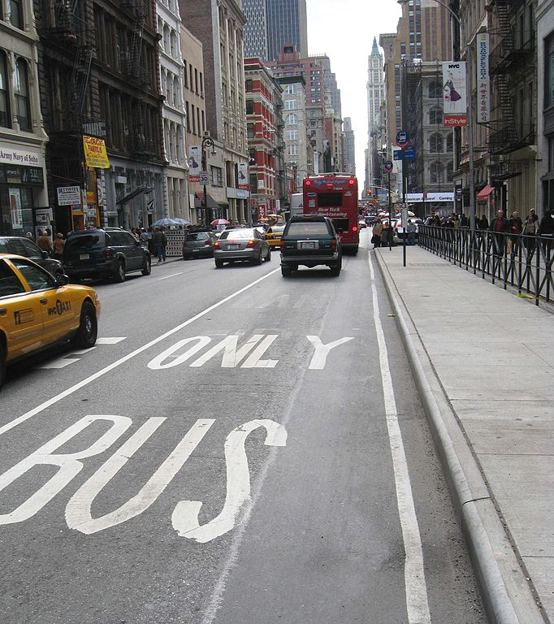
Almost 4,000 motorists a day are fined for driving in bus lanes, with the most lucrative camera making £6,000 every 24 hours.

BBC England contacted 160 authorities responsible for highways in England, 64 of which had bus lane cameras. Councils say cameras are clearly signed and they expect income to fall as drivers learn to stay out of the lanes.

A chart showing England’s most lucrative bus lane cameras was included in the BBC report based on income per day (£)
1st was Newcastle
2nd was Victoria Square W’olverhampton
5th was St Martin’s Queensway, Birmingham
In Wolverhampton, two cameras are installed to stop people using a bus lane as a short cut were making on average £4,750 a day between them.

Fines for driving in bus lanes
£130 - in Greater London. £65 in Greater London if paid within 14 days
£60 - outside London £30 discounted rate for early payment outside London
(Thanks to the BBC News 2 March 2017)

Dear Reader,
The moral of this story is to stay away and find an alternative route around Queen’s Square, Wolverhampton, or St. Martin’s Queensway, Birmingham, especially these days, with so much building work going on in the centre of Birmingham. The news story was much longer but I have edited it down to fit the page and be relevant to our area. However do look for the full version yourself, it is very interesting.
Editor Sandie
5
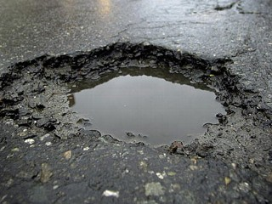
Potholes
Now the majority of winter is nearing an end we are left with the problem of potholes in our roads. Potholes are an increasing problem on Britain’s roads, causing damage to vehicles and presenting a potential safety hazard. They are a persistent concern for motorists and although it is up to local councils to deal with them they can only do so if you report them in the first place.

If you are the victim of a pothole, here is some advice
How to report a pothole:

Online - All Councils allow you to report potholes via their websites. Reporting a pothole makes the highways authorities aware of them instantly, meaning they will be able to fix them.

How to make a pothole damage claim
If your car is damaged by a pothole, you may be able to claim compensation.
The chances of being successful in claiming compensation will significantly depend on whether the pothole has already been reported. Councils have a statutory defence in that they cannot be held liable for a defect they are not aware of - either because it has not been reported to them or it has not been picked up their own system of inspection and maintenance. If you have fully comprehensive insurance, it might also be possible to make a claim via your insurer for the damage to your vehicle.

When the damage occurs you should:
If your vehicle is damaged due to a pothole, before you make a claim it is worth remembering these steps:
- Take notes – Write down all the key details including: location of the pothole, its size, shape and depth. If it is safe to do so, make a simple sketch of the area showing the position of the pothole including any surrounding features. It is also worth taking a photograph of the offending pothole.

- Any witnesses? – Wherever possible, get the details of any witnesses who saw the incident. This might help your claim.
- Get quotes – Make sure you get quotes for all repairs. Keep all quotes, bills and garage receipts safely in one place and make.

- Make your claim

- Prepare for rejection – The council or local authority may defend the claim under section 58 of the Highways Act and their right to statutory defence. If they can prove they have a regular inspection and repair system in place, they may be able to reject your claim.

- Do your research – before going back to the council to discuss the claim further, review the guidance provided on their website, check what the council is liable for and verify if they are carrying out a reasonable system of inspection and repair.

- Be willing to negotiate – If the council or local authority makes you an offer, you should seriously consider it. You may be able to negotiate; however, while you can claim the cost of repairs, you won’t necessarily be compensated for additional travel expenses or the inconvenience caused.
6

Potholes

- Consider the Small Claims Court – If your claim is rejected, you may be able to go to the small claims court. However, if you choose to seek legal advice you could end up incurring legal costs.

- Weigh up the pros and cons – It may not actually be worthwhile making a claim for compensation, if the amount is below a certain level. Before attempting to make a claim, do your research first as it could be a costly, time-consuming process.

- Keep calm – Always try to remain calm and professional when dealing with the council or local authority. And keep copies of all the letters and emails you send and receive – if you do go to court, you will have to provide a record of all your correspondence.

(Dear Reader, I have included this item on potholes simply because twice a week I have to travel down a country lane where there is a pot hole developing. Fortunately knowing where it is I can hopeful negotiate my way around it. (hopefully). )

Group President: Trevor Poxon MBE
Chair: : Martin Goad  120 Hednesford Rd, Brownhills.  01543 371516 Email: martingoad@mail.com | Committee Member - Ann Humble  253 Bosty Lane, Aldridge, Walsall . 01922 454800
Group Secretary: Glynnis Jeavons  44 Goscote Road, Pelsall 01922 691053. | Committee Member: Kath Hawker  8 Fallowfield Road, Walsall. 01922 62245
Treasurer - Karl Spooner  26 Woodside Close, Walsall 0121 357 4356 | Committee Member: Paul Honeghan  Committee Member: Alison Kimberley
Assoc Co-ordinator Clive Allsop  10 Lake Avenue, Walsall 01922 – 628339 | Co-opted Members:  Josie Hubbard-Palmer  Peter Browne
Chief Observer & Committee member:  Sarah Harrison  Black Bryony, Grove Basin,  Lime Lane, Pelsall, nr Walsall 07775-694625 | Newsletter Editor & Minutes Sec  Sandra Wootton  70a Bescot Road, Walsall 01922 621592  email@sandrawootton.flowers@gmail.com
 | Group Registered Charity no. 1082326
The opinions expressed in this Newsletter, which is published by the Walsall Group of Advanced Motorists, are those of the Editor and individual contributors and do not necessarily represent the views of the Institute of Advanced Motorists Ltd. Data Protection Act: We are obliged by law to inform members that their membership details are held on computer disc. This information is for group administration only. If any member wishes that their details are NOT to be held on computer disc, please inform the Editor forthwith.
7

