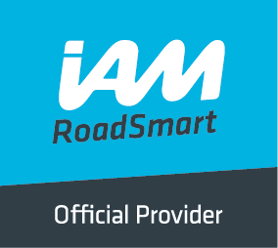
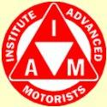
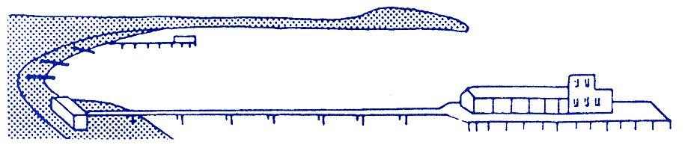
BOURNEMOUTH & DISTRICT GROUP
News @ 1096 April 2017

As many of you are aware, we now have a tremendous new website thanks to the dedicated effort made by Haydn Garwood. You can access this by putting https://www.iamroadsmart.com/groups/bournemoutham into your browser. You now have access to the national RoadSmart’s tips and comments as well as info on test passes and dates for social events being held by the Bournemouth Group.
In recent times, the Bournemouth Group has made huge leaps forward not only in the number of test passes that we now achieve thanks to our dedicated team of observers but also many of those observers have given up even more of their precious time to take the IMI test and become qualified national observers. The feedback we are receiving from associates who complete the course is that they consider it to be a very worthwhile experience and really feel that they will benefit from their “skill for life”
We wish to congratulate the following associates who have recently passed their IAM test;
Graham Austin F1RST, Norman Cooke F1RST, Robert Geach, Hazel McLister-Brewer and Phil Taylor.
Many members are aware of recent price increases in road risks insurance; some suggest that the “crash for cash” merchants are partly to blame. One of our long standing members, Nick Hanham, has written the following article and together with accompanying photos of his own car, may offer members food for thought about fitting a dash camera.
Car Dash Cams
Why have a Dash Cam in your car?
With ever increasing insurance premiums and bad driving by others a Dash Cam is becoming a necessity and not a luxury.
Insurance companies are now keen to see footage of accidents and it is often not the case of your word against another driver and vice a versa.
Most of the time the camera will tell the truth about who is in the wrong.
This will also help protect your No Claim Bonus (NCB) and even prevent a claim being part paid by you.
Recently a friend of mine was stopped at traffic lights and the all too common tail gater pulled up behind with a foot on the brake.
A slight distraction and the foot slipped of the brake and touched the accelerator pedal, the car, still in gear, shot forward into my friend’s car causing £700.00 worth of damage.
Fortunately my friend had a forward and rear facing camera and the footage easily proved that he did not move, but the other car did. There was no cost whatsoever to my friend and no reduction of his NCB.
It is often said that any argument by a person in the wrong is immediately silenced when bad driving is demonstrated on video. However, do not forget your driving will also be recorded.
This hopefully will also stop Road Rage.
Dash Cams are readily available at good motor shops, Halfords, EBAY and Amazon and range from £30.00 upwards.
I would suggest that a two camera system is best as it gives forward and rear coverage.
Also a built-in microphone to catch any comments at the time of an incident such as location and registration number, in case it is not picked up.
Date and time will be recorded on the video.
Do not forget to adjust for summer and winter clock changes and leap years.
Installation: DIY, a good motor shop or Halfords will do this for you; charges may vary.
I have a Falcon F360 forward and rear camera which is the same model that one of my associates had.
I was so impressed by the camera I purchased one from Amazon and fitted it myself.
I have now added a second camera to my wife’s car.
The camera comes complete with the digital recording chip.
The chip has a large capacity; however the clever part is that when it is full, it deletes the earliest recording and adds the latest one. The occasional formatting of the disc ensures it is working correctly.
The camera, when wired in, usually to a cigar lighter point, switches on when you turn on the ignition and turns off when the ignition is switched off.
If you wish, you can switch the camera on when the car engine is turned off.
You also have the facility to switch between day and night vision.
You can also play back the build-up to an incident in the car on the Dash Cam.
Standard camera chips can be interchanged so you can keep a specific recording if you wish.
The chip will play back on the Dash Cam, PC or laptop.
You also have the option to save an incident to your PC or laptop.
For a small investment the Dash Cam can give you a certain amount of peace of mind and hopefully save on any confusion at an incident. Nick Hanham (Observer).

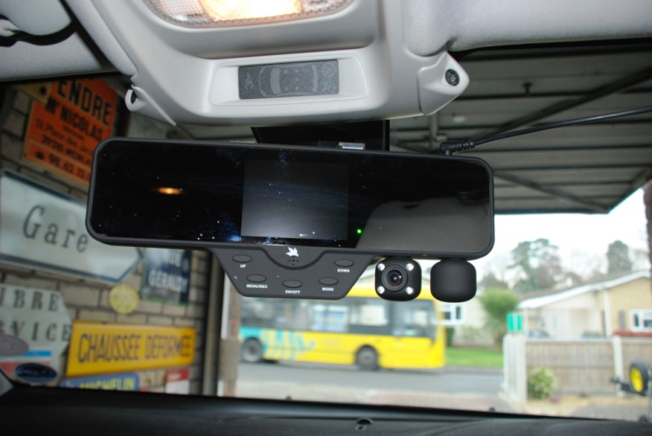
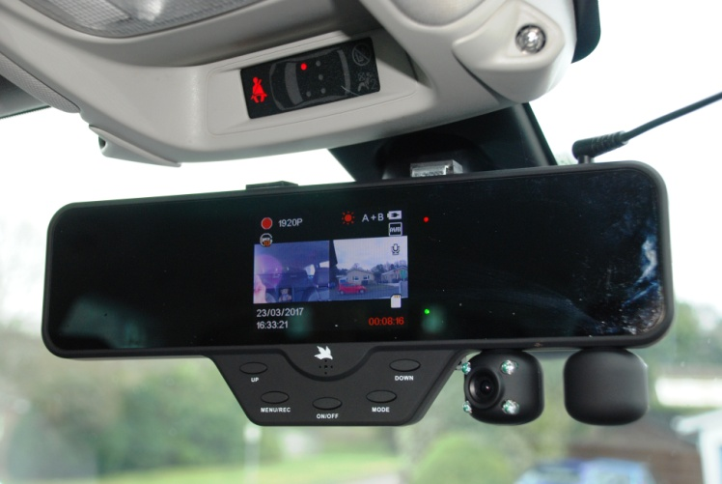
1) The Falcon F360 mounted in my car. 2) Close up of the cameras and mirror.
The mirror is part of the camera and clips onto the existing mirror. The mirror is for a day or night vision.
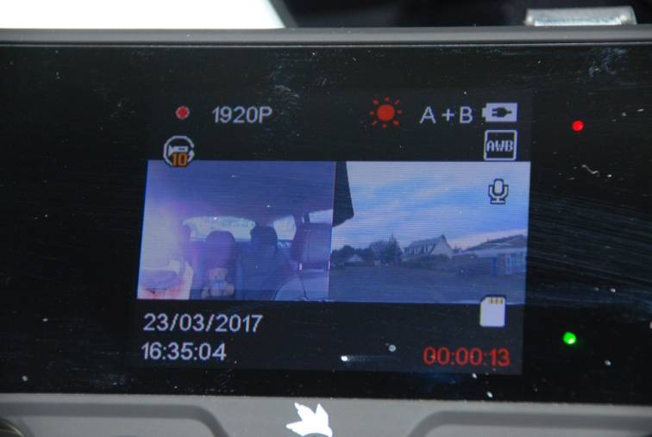
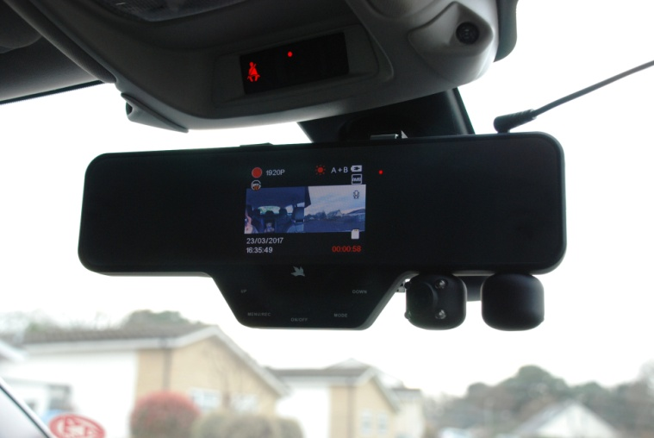
3) Forward and rear camera image. 4) The cameras are part of the mirror and from the outside looks After one minute the image disappears and the mirror works like it is a normal part of the mirror.
as a normal mirror.
Image quality is good when viewed by eye and not via this shot.

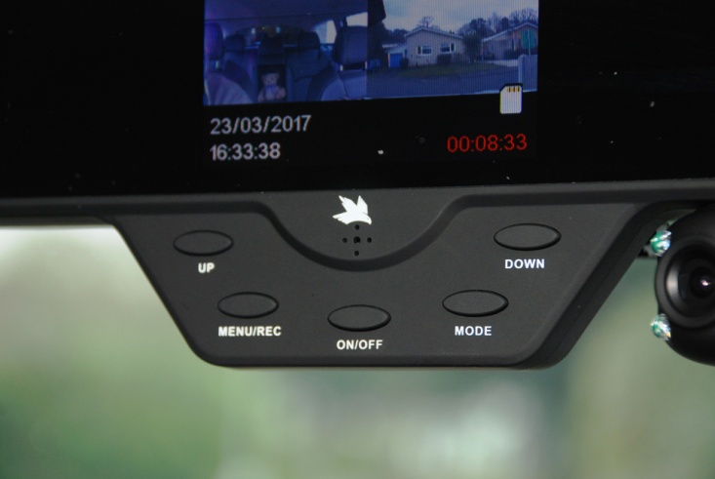
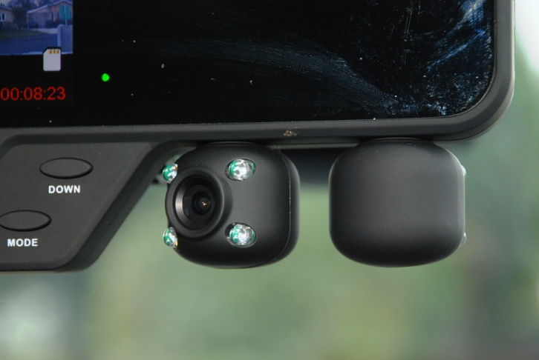
5) Dash Cam control panel. 6) The forward and rear camera.
-----------------------------------------------------------------------------------------
Many of you know Mike Staton who, for many years, has organised the social side for the group. Mike is also very involved with the Bournemouth North Rotary Club and, once again, is helping with the organisation of their forthcoming Donkey Derby Day. Our local IAM together with Bournemouth & Wessex Advanced Motorcyclists and SafeWise will be represented at this event and we hope that as many of you as can will come along to support Mike and the group. Observers who can spare an hour or so to help out on the day would be very much appreciated.

AFC BOURNEMOUTHS CHERRY BEAR TO LAUNCH

MAY DAY DONKEY DERBY, DOG SHOW AND FETE

AT PELHAMS PARK, KINSON on 1st May
The annual May Bank Holiday Monday Donkey Derby, Dog Show and Fete at Pelhams Park, Kinson, which has been organised by the Rotary Club of Bournemouth North for over 30 years, is fast approaching. A great day out for people of the area with so many attractions this event raises thousands of pounds for local charities each year.
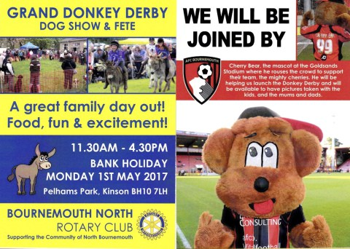The event is open from 11.30am until 4.30pm.
In recent years we have been joined by the ‘Caring Canines’ Dog Show and we are delighted that they will be joining us again this year. You will find them alongside the tennis courts so please give them a visit and take your dog along for some of the fun entries. Entries £1.00 per class payable on entry into the ring. Judging from 12.00 noon.
As usual the Donkey Races will be taking place in the main arena providing lots of fun and entertainment and a big thank you to all the jockeys coming along to help. You can have a small flutter on the races and the younger children can have a donkey ride, which has proved very popular in previous years.
Why not enjoy a cup of tea and a slice of cake, an ice cream or even one of Chef Tony’s famous beef burgers while you relax and listen to the band.
Over the years we have supported many local groups including Cherry Tree Nursery, Brendon Care Lunch Club, Kinson Food bank, Pelhams Community Group, Bournemouth Blind Society, Woofability (dogs for the disabled), the MS Society at Parley, Kingsley House Dysphasia Support Group, Bournemouth Scouts, Macmillan Caring Locally, Bournemouth Hospital Charity, the Poppy Appeal and lots, lots more too numerous to mention. Many of these groups will have stalls on the day so please support them as they are all run by volunteers who give up hundreds of hours each year helping their causes.
Many of the stalls will be run by Bournemouth North Rotarians with the help of wives, husbands, partners and friends and so a big thank you to all of them as without their assistance the event could not take place. Why not pick up a bargain book, a delicious cake or some plants for the garden or try your luck on the tombola. Every penny raised goes to support local organisations.
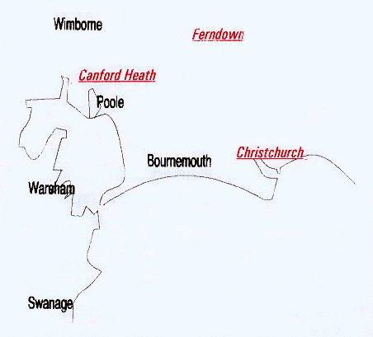
Disclaimer: The views and opinions expressed in News @ 1096 do not necessarily state or reflect the views of the Bournemouth & District Advanced Motorists Group.

