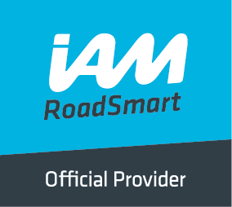
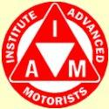
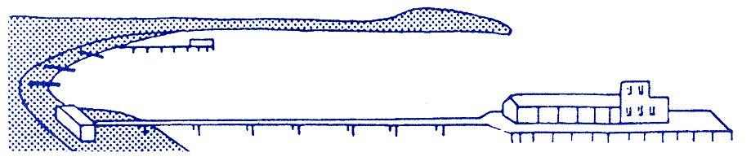
BOURNEMOUTH & DISTRICT ADVANCED MOTORISTS
News @ 1096 December, 2016
In November, we were pleased to welcome Brian Austin from the Dorset Road Safety “No Excuse” team whose talk gave a most interesting insight into the work of the road safety team.
Details on the Dorset for You website describes the team as follows:
'No excuse' is a carefully researched Dorset Road Safe partnership project that delivers additional traffic enforcement, publicity and education programmes aimed at reducing the number of people killed or seriously injured on Dorset's roads. Launched on 15 January 2010, it combines evidence-led high-profile additional enforcement with a carefully planned long-term publicity and education programme that aims to positively influence motorists' attitude and behaviour.
The 'no excuse' project focuses on influencing the behaviour of four specific groups:
- Car drivers (particularly young male drivers)
- Car passengers
- Motorcyclists
- Business/delivery drivers
The key target behaviours to be addressed are:
- Mobile phone use whilst driving
- Non wearing of seat belts
- Bad, dangerous and careless driving
- Drink and drug driving
- Inappropriate speed
- You may have spotted these signs when driving around the county. They are temporary signs placed at the roadside to remind drivers that there is no excuse for careless or dangerous behaviour whilst driving.
- 'No excuse' Surround a Town is a day-long operation, concentrating on mass enforcement in and around one town.
- Marked and unmarked police patrols are located on the main routes in and around a town to catch drivers committing driving offences. Those caught not wearing their seatbelts on the day have the option to attend a free short educational presentation on the risks and consequences of being unbelted, instead of receiving a fixed penalty.
- Representatives from all of the Dorset Road Safe partners give road safety presentations to local schools and talk to the public about the 'no excuse' project. Dorset for You
However, in spite of the team’s best efforts at re-education, there are some drivers who refuse to drive considerately and respect the rules. The Dorset Road Safety team, whilst covering the whole county, cannot be everywhere at once and so rely on members of the public to supply information on individuals who are considered to be driving in an inappropriate manner. If you can supply some detail of the vehicle i.e. registration number, colour etc and perhaps an approximate time of day the vehicle is seen, particularly if this vehicle is being repeatedly driven badly, then the team will make every effort to make sure they are in the vicinity to catch the driver concerned. Whilst the Road Safety Team is made up of civilian operatives without powers of arrest, the Police have also recently launched Operation Dragon to target and prosecute drivers who choose to ignore the Road Safety Team’s advice and education efforts.
All drivers want to get from A to B safely and, thankfully, the majority of drivers always drive considerately and within the law. Sadly, however, just recently there has been at least one serious accident involving the use of a mobile phone at the wheel. The IAM has been quick to respond and has issued the following statement:
IAM Surety adopts a zero tolerance policy towards penalty points for mobile phone usage whilst driving
The risk of using mobile phones while driving has been very prominent in the media recently, following the tragic quadruple fatality caused by an HGV driver using a phone at the wheel. From this point forward our Insurer, IAM Surety, will be unable to offer our exclusive ‘members only’ insurance scheme to any members who obtain points for using a mobile phone while driving. This will be a permanent exclusion. Please do be sure to inform your local groups, so everyone understands the position. We support this positive step towards making using a mobile phone while driving socially unacceptable.
Our Road Safety Week Driver Assessment Giveaways
Road Safety Week is the UK’s biggest road safety event, co-ordinated annually by Brake and involving thousands of schools, organisations and communities each year. As part of our activity for #roadsafetyweek, taking place from 21 – 27 November, IAM RoadSmart will be offering grandparent-grandchild pairs free driver assessments. The package for each winning grandparent-grandchild pair will consist of one regular driver assessment and one mature driver assessment, with a combined value of £98. To be in with a chance of winning one of these bespoke packages, either grandparent or grandchild (or a family member) will need to submit a reason on behalf of the both of them, briefly summing up why driving is important to them. Photos also welcomed.
Reasons and photos can be submitted via Twitter by tweeting the @IAMRoadSmart account using the hashtag #drivingthroughtheages (if you cannot fit your reason into one tweet, you can use multiple tweets and number them), posting on our Facebook wall at www.facebook.com/IAMRoadSmart or emailing events@iam.org.uk The competition remains open for the entire week and entries will close at 11.59pm on Sunday 27 November. Winners will be announced on Monday 28 November. Please share this across your social feeds and let anyone know who you think might benefit from this giveaway. Do also look out for other #roadsafetyweek activity on our social channels, which will consist of key road safety issues, stats and facts and also share these.

Goodbye autumn leaves
It may seem a little late to be discussing autumn weather but with the impact of the Indian summer, all of the seasons have been pushed back a spell. Many of us will be taking to the road this week on the daily commute. Here are some tips to prepare drivers and riders on this late leaf falling season from IAM RoadSmart’s head of driving and riding standards Richard Gladman.
- Check your motor battery. In winter we often place a strain on the battery with lights, heated screens, seats and the air conditioner to demist and keep us warm and if there is any sign of your car battery struggling now, it is likely it will let you down as it gets colder.
- That low winter sun can be an issue. Keep a pair of sunglasses in the car and also make use of the sun visor too. If you are dazzled slow down immediately.
- Now is the time to check your antifreeze levels. The good thing about antifreeze is that it contains additives that prevent corrosion and improve summer cooling too.
- Top up the windscreen washer with de-icing additive.
- Check your windshield wipers. If they begin to blur the front/ rear window, it’s time to replace them with new ones.
- Have a look at your car headlights. It is dangerous for you and for the other road users if your lights do not work properly.
- Leaves or pine needles on the road can turn into a mushy film which obscures potholes, road markings and increases stopping distance. Anticipate problems when you approach woods and trees and slow down until the road is clear.
Richard said: “As the temperature drops your car is a nice cosy place to be when it is working properly and sound preparation will help your journey go smoothly. Frosty mornings and falling leaves might be picturesque but they can cause all sorts of problems, particularly for two-wheeled road users. Give motorcyclists and cyclists more room and anticipate their actions. Drivers also need to stay alert for blocked drains and localised flooding at this time of year. Your aim should always be to have a clear view of the changing seasons around you and for other road users to be able to see you.”
Since our last newsletter, we are delighted to announce that 3 more associates have passed their IAM test; many congratulations to Robert Kirkham, Jason Burch and Sophie Bentall.
For our December meeting this year, we have decided not to have a speaker which will give everyone the opportunity to chat with one another and enjoy some Christmas mince pies etc. Please do come along to Pelhams on 1st December at about 7.30pm and bring your partners, neighbours and friends.
As usual, there will not be a meeting in January but our social gatherings will re-commence on 2nd February at our new starting time of 7.45pm. We hope you will all come along and support the group.
Wishing you all the very best for Christmas and for a happy and healthy 2017.
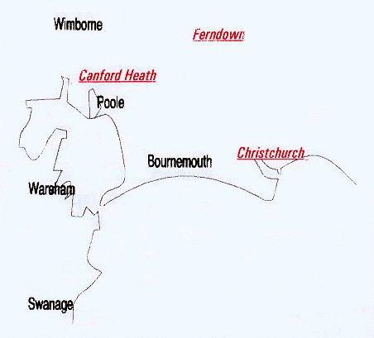

Disclaimer: The views and opinions expressed in News @ 1096 do not necessarily state or reflect the views of the Bournemouth & District Advanced Motorists Group.

