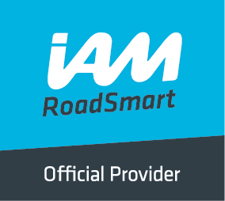
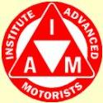
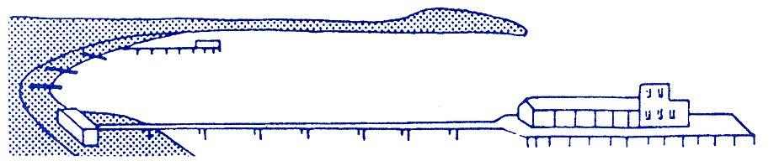
BOURNEMOUTH & DISTRICT GROUP
News @ 1096 June 2016
At our June meeting, we were treated to a very honest and comprehensive insight into the pressures and concerns of a present day car dealership by Robin Webb, the Principal of Keith Motors, one of our local Ford Dealers.
Robin explained how the competition for new sales has reduced the dealer profit over the years and how a dealer now has to try to persuade a customer to return for servicing as required by offering “add-ons” in the form of a car valet, an air freshener and a newspaper to read while you wait!
The meeting was well attended and everyone seemed to enjoy the evening.
On Thursday 7th July, we are being given a talk by Louise Jones from the Lewis Manning Hospice. This will be at our now usual start time of 7.30pm at Pelhams. Please make every effort to come along and support your group.
Mercedes Museum
Do you like or loathe museums? The ones we generally like are engine related; it could have wings on it or be road going with 2 or 4 wheels but it must have an engine.
The Mercedes Benz Museum has primarily 4 wheel exhibits which are all housed in the in the most innovative circular building in Stuttgart.
We arrived soon after it opened for the day at 9am, fondly imagining that we would have “done the tour” by lunchtime only to find at 5pm we still hadn’t seen everything.
We started off by following our eyes which led to a whole host of brand new versions of all the current models together with price tags. After much drooling, we decided we ought to stop dreaming and progress to the actual museum. We then did the unthinkable and looked at the guide leaflet and realised that the starting point for the museum was the 8th floor and not the 1st.
It all begins in the late 1800’s with horse and cart and drawings of Karl Benz’s first working engine and a model of the same. There were also drawings by Gottleib Daimler of his first working engine. They both went their independent ways for many years and, apparently neither knew of the other’s work. As Karl Benz was the first to patent a petrol driven two stroke combustion engine, he is considered to be the inventor of the “motor car”. Among his many inventions that he went on to design and patent were the spark plug, radiator, clutch and gear change. During WW1 Benz and Daimler were producing military vehicles, aero engines and munitions, still as independent companies. There are models of all these and various archive files together with some of their original vehicles.
The museum archivists have incorporated some of the social history of the time to help visitors appreciate the hardships that workers and companies endured. In 1923 the companies of Daimler and Benz were forced to combine for economic reasons.
A customer called Jellinck had purchased a Benz racing car and, as it won at its first outing, was christened Mercedes after his daughter. From then onwards the cars all became known as Mercedes Benz.
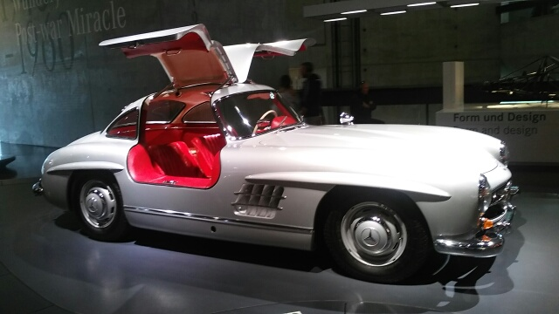
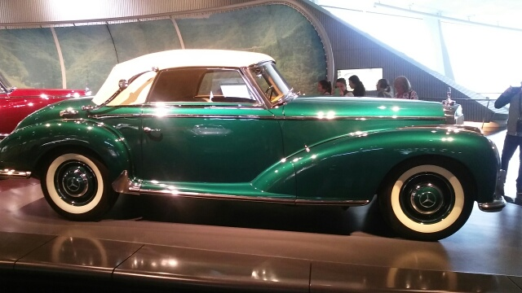
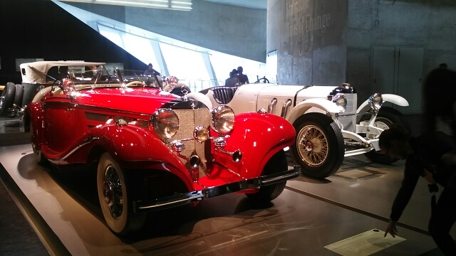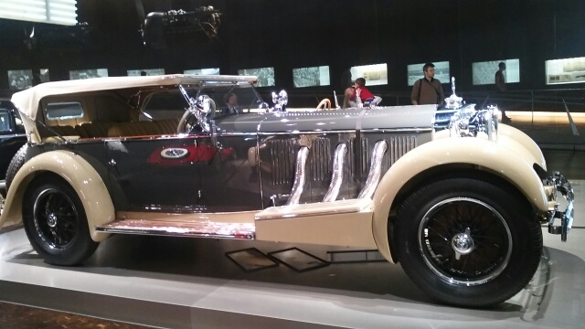
As one progresses through the museum there are so many gorgeous cars to see; many from the 20’s and 30’s when they had such individual styles. Hand in hand with the cars, are the commercial vehicles with their many variants; coaches, fire engines, police and ambulance and even a refuse truck, each with their individual history. There are cars from the “Stars”, or more accurately, greater and lesser personalities. The “piece de resistance” is the race car and truck gallery. There are pre WW2 race cars all the way up to and through the noughties. There are world touring car winners and many from the DTM series (Germany’s own touring car championship). Alongside these are Le Mans 24hour winners and truck racing winners from when Mercedes won the world truck championship (7 times in all).
To finish off your visit to the race gallery, you can take a ride in one of their two race simulators.
For those who are feeling flush, you can proceed to the basement and choose your new car from almost their entire production range. John Williamson

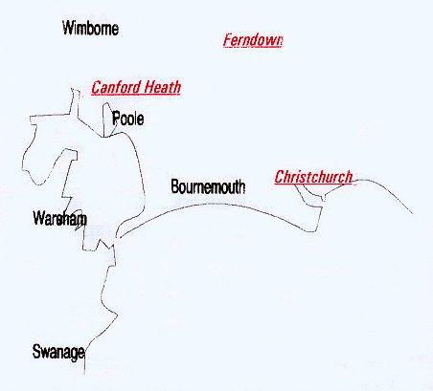

Disclaimer: The views and opinions expressed in News @ 1096 do not necessarily state or reflect the views of the Bournemouth & District Advanced Motorists Group.

