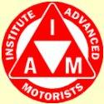
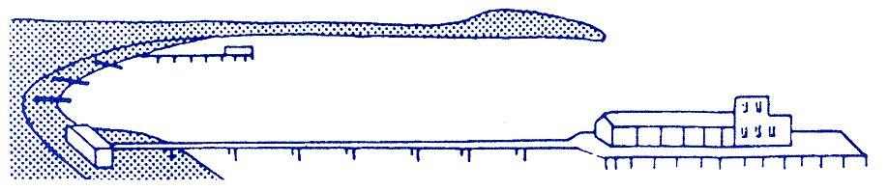
BOURNEMOUTH & DISTRICT ADVANCED MOTORISTS
NEWS @ 1096 October 2016
The speaker at our forthcoming meeting on 3rd November will be Brian Austin who is the Dorset Police Road Safety Operations Manager. The meeting will commence at 7.30pm at our usual venue; Kinson Community Centre, Pelhams Park, Millhams Road, Kinson BH10 7LH. Please do make every effort to come along and support the group and the speaker and bring your partners, friends, neighbours etc.
We wish to congratulate Keith Gibbons, Kate Mason, Luke Smith, Julie Bell (Salisbury Group) and Honor Williams who have all recently passed their IAM test also extra congratulations to Edward Delaine, Bob Plumridge and Haydn Garwood who all gained a F1rst.

BOURNEMOUTH & DISTRICT GROUP OF ADVANCED MOTORISTS
Minutes of the 39th Annual General Meeting held on Thursday, 6th October 2016
Present: 16 Members & 1 Associate
Apologies for Absence: Edward Delaine, Nick Hanham, Mike Heybourne, Alison Shelton and Sue Whitcher.
Meeting commenced 7.55 p.m. with apologies from Chris Dale for his late arrival due to his car breaking down.
Minutes of Annual General Meeting 1st October 2015
The minutes of the 38th AGM were adopted as a true and accurate record of that meeting by a majority show of hands. There were no ‘matters arising’ for discussion.
Chairman’s Report
Chris gave the report in view of Sue’s absence due to illness. He reported that the Group was in good health and that steps had recently been taken to absorb members following the closure of the Salisbury Group earlier this year. To date four members had expressed an interest in transferring to Bournemouth Group.
It was reported to the meeting that Sue wished to stand down from her role as Chairman and so on behalf of all the Committee and Members, Chris recorded a huge thank you to her for all her years of work on behalf of the Group. He was pleased to say however that Sue was prepared to continue to serve for another year as a Committee Member.
Chief Observer’s Report
Richard presented the Chief Observer's Report for 2016.
He started by thanking all Observers for their continued sterling work for the Bournemouth Group, a work load which seems to increase as each year goes by.
Currently we have 16 Observers, Nigel Burden our only working Approved Driving Instructor having retired as an IAM Observer earlier this year.
The 16 Observers are made up as follows:-
7 IMI National Observers, 3 New IMI Local Observers qualified this year, 5 Group Observers and
1 in training as a new IMI Local Observer.
Bearing in mind all Observers have to be qualified by 31st December 2017 there is an ongoing training program which is on course to be completed within this time.
We still have 7 IMI National Observers and one has re-qualified this year (Richard himself)
3 Group Observers are undergoing training as IMI National Observers; 3 Observers new to the group have qualified as IMI Local Observers and one more is undergoing training. The remaining two Observers are waiting to be trained to re-qualify, one as an IMI Local Observer and one as an IMI National Observer. Out of the 7 IMI National Observers, 4 are Local Assessors who conduct the training in house for the Local Observers and assess when the candidates are fully qualified as Local Observers. The IMI National Observers are qualified externally.
At this time we have 9 new Associates waiting to be allocated their Observers, most of whom are coaching two Associates each plus some Observers also acting in a training role. Currently 21 Associates are allocated to Observers. The Bournemouth Group seems to attract new Associates very easily without the necessity to advertise, unlike other areas.
Year ending June | 2014 | 2015 | 2016 | Current year  July to Sept
Test Passes | 9 | 10 | 16 | 9
Firsts | 2 | 3 | 5 | 2
Masters | 1 (Distinction)

Richard believed these results show a marked improvement for this year and he thanked all Observers and Trainers for their hard work and dedication.
Personal thanks from Richard were given to Haydn Garwood for working hard to develop the new Group Website after some initial setbacks with it and to David Hodges who works tirelessly sorting out the allocation of Associates whilst sorting out hiccups from HQ as well as having a training role and fitting in time to coach his own Associates.
Treasurers Report
A copy of the Group’s Financial Statement for the year ending 30th June 2016 was circulated to all attendees. Pauline then explained some of the key elements:
Income
Subscriptions from Members and Associates totalled £870
Gift Aid - HM Customs & Excise rules allow us to claim 25% of membership fees for anyone who is a UK taxpayer and gives permission for us to claim Gift Aid in respect of their annual subscription. Forms were available from Pauline for anyone who hasn’t already done so and would like to add this tax concession to our funds.

Donations are generally payments made through lapsed members’ bank accounts where these have not been cancelled by the member. Once national membership lapses then local membership also expires.
Income from HQ is the Group’s share of the Skills for Life fee charged to new Associates.
Expenditure
Stationary, postage & telephone is the total sum spent by all Committee members during the year. Most members are now on email and we now only post newsletters to 8 members, quite a drop from the 42 we were posting when Pauline first starting doing the newsletter in 2011.
Insurance costs have risen slightly but room hire is reduced slightly owing to us using a smaller room on one occasion.
Speaker Expenses have increased as we are finding that most speakers expect to have at least their travel expenses covered. However, some speakers are happy for us to make a donation to their charity and this year Trevor Clements asked us to donate to the Mission to Seafarers.
Pauline also reported an increase in Web Hosting charges but hoped that savings can be made in the current year after Haydn’s re-vamping of our website.
Finally it was reported that the Group had made a £134 surplus for the year which compared to a small deficit of £63 the previous year.
The accounts were duly approved by the members present and signed by Chris Dale on behalf of the Chairman.
Election of Group Officers
Post | Holder | Standing for Re-election | Nominated by | Seconded by | Elected Y/N
Chairman | Sue Whitcher | No | n/a | n/a | n/a
Chairman | Chris Dale | elect | Richard Jolly | David Baker | Yes
Secretary | David Baker | Yes | Richard Jolly | Roger Brigham | Yes
Treasurer | Pauline Williamson | Yes | Chris Dale | Mike Staton | Yes
Committee Member | Roger Brigham | Yes | Richard Jolly | David Baker | Yes
Committee Member | Nick Hanham | Yes | David Hodges | Richard Jolly | Yes
Committee Member | David Hodges | Yes | Richard Jolly | Roger Brigham | Yes
Committee Member | Richard Jolly | Yes | David Hodges | Roger Brigham | Yes
Committee Member | Mike Staton | Yes | Pauline Williamson | Chris Dale | Yes
Committee Member | Sue Whitcher | Yes | Chris Dale | Richard Jolly | Yes

The current Officers and Committee resigned prior to the above nominations being agreed by a unanimous show of hands by meeting attendees.
Any Other Business/Open Forum
Group’s new Website.
Haydn reported on progress with this:
Initially there were teething problems with IAM HQ’s new website which delayed his work. Subsequently a Southampton based company – CDD has been appointed to handle the changes but they have also caused two 48 hour delays to Haydn’s progress. He will advise all members once the new site is up and running. New photography is currently being undertaken and the suggestion was made that the Group’s Officers and Committee should be photographed for inclusion.
Social Meetings start time.
Following several expressed concerns from members there was an open discussion about the experimental change of meeting start time from 8.00pm to 7.30pm introduced earlier this year. Some members found it difficult to arrive by 7.30pm due to work and other commitments so it was agreed that the Committee would review this issue and a potential compromise of 7.45pm was suggested. Please note however that this change would take effect from the February 2017 meeting at the earliest.
It was the opinion of the meeting that speakers should be given a guideline timescale of 1 hour including questions; that no official break time was needed and that everything should ideally be wrapped up by 9.30pm.
Membership Issues
Pauline reported that we had lost 9 members over the last year for unknown reasons. The Committee will discuss how we might seek feedback in future. Chris re-iterated that the main solution to the problem of membership numbers was to appeal to the younger generation. The meeting was informed that HQ were already taking action on this and had appointed Eloise Peabody-Rolf, an 18 year old ‘graduate’ of the Under 17 Car Club, as an ‘ambassador’ to visit Groups around the country and develop ways of encouraging young people to take the IAM test. Various suggestions were forthcoming on this issue including ‘free’ courses for under 25’s and encouraging franchised dealerships to put their (frequently young) sales staff through the course to safeguard their customers and the expensive cars they were regularly demonstrating.
The very valid comment was made that people who played golf and tennis often used professionals to help them improve. Why did this not apply to driving?
Group Strategy
As the incoming Chairman, Chris announced that he would work with the Committee over the next few months to come up with a strategic plan for the expansion of the group; taking account of Observing limitations but making pro-active use of the Group’s healthy financial reserves.

Newsletter
The often repeated plea for members to contribute articles for the Group’s newsletter was made; in particular a suggested theme was ‘My First Car’. There was a discussion as to whether the newsletter should be emailed to members or simply posted on the new website when it was up and running. The majority view favoured doing both.
Meeting closed at 9.30pm

Following the appeal at the AGM for newsletter articles, one of our stalwart observers, Brian Chapman, sent the following article about his “First Car”

MY FIRST CAR

My first car was a BMW - but not a BMW as we know it. It was an Isetta 3 wheeled bubble car in bright red. I bought it 52 years ago and commuted around London in it, taking great joy at nipping in and out of the traffic among the proper cars. I suppose it was the equivalent of today’s Smart Car, but much less sophisticated and lethally dangerous.

The one door opened at the front and the steering column hinged back with it. The gear lever stuck out of the side wall on the right hand side. It was supposed to have synchromesh, but it worked only when changing up, so it was necessary to double-de-clutch when changing down. It had an uncomfortable bench seat, and, of course, no seat belts. There was a canvas sunshine roof that folded right back - what luxury! There was no petrol gauge. When the engine coughed, you reached behind you and flipped a switch from main to reserve tank.

It was driven by a single cylinder 300cc BMW air-cooled motorcycle engine, which was totally reliable in all weathers. There was a heater that consisted of a tin box wrapped around the cylinder block to get hot air into the cab. Unfortunately the exhaust always leaked so it pumped exhaust fumes into the cab also.

My first daughter was born while I had the Isetta and we used to put her in the carry cot on top of the shelf over the engine behind the seat - not strapped in at all - and the wheels for the cot on a roof rack, making the vehicle even more unstable than it already was.

The windscreen wiper motor failed and I could not afford to replace it for a while, but fortunately the mechanism was open under the screen, so it was possible to work the wipers with my left hand while steering with my right.

The bearings on the single back axle collapsed once and scored the axle. Fortunately my friend the local blacksmith was able the run some weld onto the axle and machine it back down so I avoided the cost of a new axle in addition to the bearing. Unfortunately, he did not heat treat it properly and shortly afterwards the axle snapped as I was cornering and the back end hit the tarmac with a thud!

Driving in snow was interesting - the front wheels were OK in the ruts made by other cars, but the back wheel, which provided the drive jumped around on the frozen snow in the middle.
I drove it initially on a provisional licence which was supposed to be OK for 3-wheelers, but the police eventually gave me a ticket because mine had a reverse gear which allegedly meant you had to have a full licence. In fact the law was so confused on that issue that I got away with it and anyway passed my test the following week.

I would love to drive one again just to remember how it felt - but only on a safe track, not on the road!
Many thanks to Brian

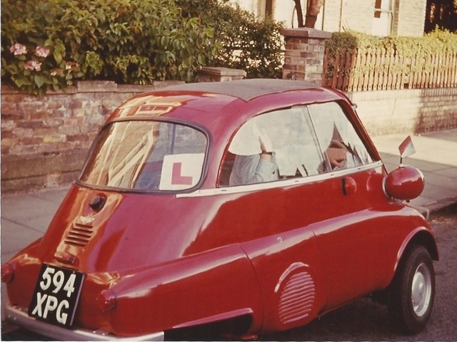
Maybe other members have similar reminiscences they wouldn’t mind sharing with us; if so please email to Pauline at pcbwilliamson@btinternet.com or pop them in the post to Mrs P Williamson, Neats Byre, North Trigon, Wareham BH20 7NZ – all contributions most gratefully accepted!

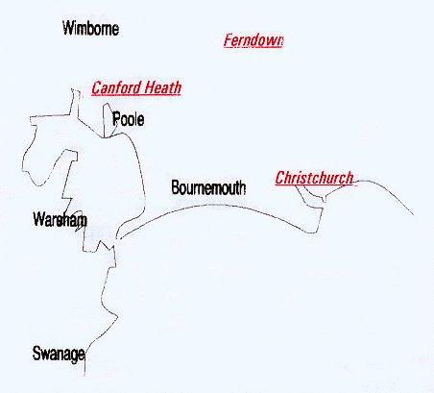

Disclaimer: The views and opinions expressed in News @ 1096 do not necessarily state or reflect the views of the Bournemouth & District Advanced Motorists Group.

